A Simple Spring Compressor

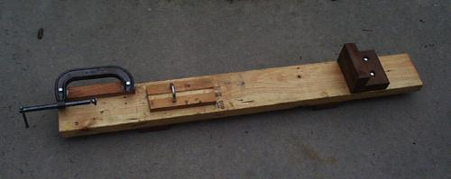
Since this is a simple design, I'll just list the parts I used with a few tips and measurements. Those, along with the pictures below, should be all you need to build a similar compressor of your own. This one is designed to be able to accommodate larger guns in the future.
Parts
6 1/4" flat washers 6 4"-20 hex nuts
1 6" quality C-clamp 1 5/16" x 2 1/4"W x 4 1/4"L U-bolt
4 3"-long 1/4"-20 hex-head cap screws 1 3" length of 1/4" id silicone tubing
1 4' 2x6 board
1 8" length of 1x4 with 3/4" dado about 1/4" deep (for the saddle board)
Measurements
2.5" from clamp pad to saddle board (or as needed for your application)
28" from clamp pad to stop-block (or as needed for your application)
clamp mounted on 0.75" thick pad
Some Tips
Finishing with some polyurethane varnish lets you clean up tar and oil more easily.
Using a quality clamp will help eliminate any slop and tendency to jump off track
Put the tubing on the U-bolt using Vaseline.
Just tack down the saddle board to support the gun above the main board so that you can move it for different size guns if necessary. For the same, don't permanently affix the L-shaped stop-block. Purchasing 1/2" longer bolts will eliminate all the countersinking.
