How to care for your B-19 Gamo Hunter and Shadow Series
By Charlie

You will find some pictures in this document giving you some idea of what your gun looks like internally and identification of some of the lube points.

Your gun has been lubed both internally and externally during the tuneup process. Internally it should never have to be lubed again unless it is tuned again in the future. For all intents and purposes, it is self lubing and should last for years. Use Rem-Oil on the wood and exterior metal.

Externally it should be lubed about every three thousand rounds or so, or at least once a year. It is a simple procedure. If your gun is put away for long periods of time, it should be fired every three months or so with about 5 shots or so it may lube itself.

The best lube to use is a mixture of moly and 30wt non-detergent oil. Mix it 1 teaspoon of moly to three ounces of oil. Lube very sparingly. I use a tooth pick dipped it the mixture and put only a drop or so. If moly is unavailable, use 30wt non-detergent oil.

First remove the stock by removing the two Phillips screws located in the forestock and the rear screw in the trigger housing. The assembly lifts out of the stock although sometimes it is a tight fit at the trigger end. Use a good Phillips screwdriver as these screws are installed with LocTite during final assembly to keep them from loosening.

Lube all of the pivot points where you see the rivets, the long thin metal piece that goes from the cocking arm to the trigger (g or d), three or four drops spread out into the trigger mechanism from the trigger (bottom)side and the little spring, both sides of the cocking pivot point or yoke, the barrel latch points taking care not to get any into the muzzle or port, three drops into the slot that you can look into and see the spring at the cocking foot and a drop or two on the cocking foot itself (where the light green arrow is).

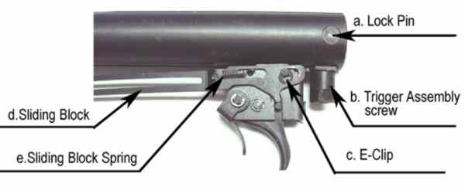

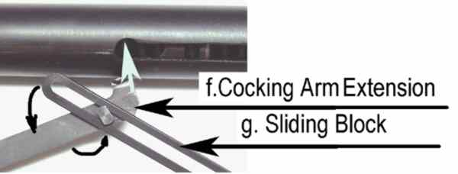

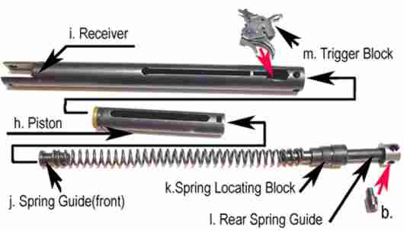

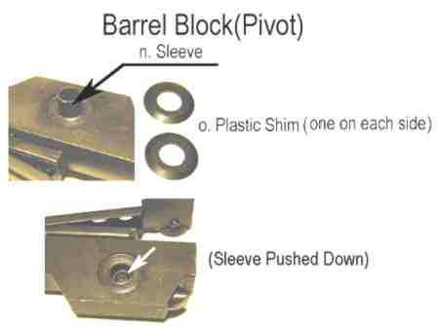

Cleaning the bore

The best thing for cleaning the bore is GooGone. You can find it at just about any hardware store, Wal-Marts and K-marts I think, and places like Home Depot or Lowes.

The best way to do it is to use is a piece of trimmer line, the plastic or nylon line used on grass trimmers, cut to the length that is best for you, heat it on one end to create a small ball and on the other end cut it to a point. Then using .22 bore cleaning patches, push the sharp end of the line through the patch(s), then put some GooGone on the patches and pull them through the bore. Do this several times first with the ones with the GooGone and then dry patches until they come through clean. By the way, the barrel doesn't have to be cleaned very often, maybe every three or four tins of pellets. The lead deposits act as a lube for the pellets.

Note Note Note

Your freshly tuned B-19, if you ordered the super tune, will have a new Tarantula spring and a new Apex seal. Both of these will require a period of time to break in. It is possible that it may also smoke and possibly be loud the first few shots or so. The break in period is usually somewhere between 500 and 1000 pellets.

Initially, the velocity may drop a little but as the seal breaks in and mates to the compression chamber it will increase, usually somewhere between 25 and 50 fps. This is normal. Also, the cocking will get a little easier as will the trigger pull. If you ordered a trigger tune, it will already be smooth but may still improve even more.

Many breech seals will show some chafing on the ridges and this is not unusual and doesn’t have any adverse effect. When I see it, I check to make sure they are sealing.

There is a trigger adjustment in front of the trigger. It is a very small screw and hard to see. Take care not to set it to light when adjusting. Screwing it in shortens the pull in the so called second stage. I set it so that it should be good enough for most people.

You may notice for a short period of time an oil mixture weeping its way out of the trigger assembly. This is normal as the trigger is saturated with the mixture and allowed to drip dry and the trigger housing is patted dry externally during assembly. Sometimes not all of the lube drips out initially. Just wipe it off with a tissue or rag.

Thank you for letting me be of service to you.

Charlie

