Some have asked how to rig a bulk fill kit for your 20 lb. and up bottles.>>
June 6 2004 at 1:27 AM Gene Sunday

Start with a CGA-320 to 1/4 pipe adapter and plumb from there.
If you keep your rig short then you lose less gas when you purge the system after filling your bottle or tube.
You can dip tube a bottle but you'll lose from 2 to 5 lbs. of every bottle. Use a filter in your system to keep trash out of your gun. A small mesh SS screen is available for this at your welding supply.

Any welding supply house should have the fittings you need.
CGA-320 to 1/4 in. pipe is the easiest to start with.
Don't forget a gasket while you're there!!!

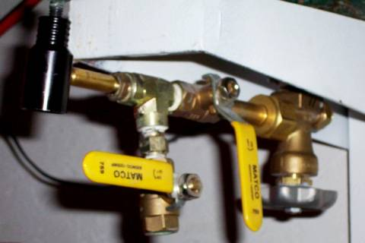

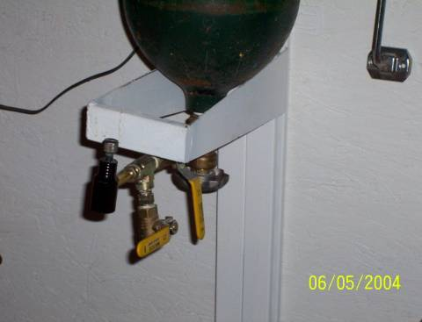

CharlieDaTuna and I were talking about bulk filling
May 30 2004 at 8:48 PM

gas guns and I asked a question that Charlie suggested I post on the forum. I have a couple of co2 bottles that are used to provide carbonation in soft drink dispensers, like Coke-in-a-bag machines. Is the co2 that I buy bulk from the welding supply house the same co2 used to bulk fill "liquid" co2 in a gas gun?
We're wondering, what's the drill? Right side up for co2 gas...upside down for co2 liquid?
When I use co2 on my wire feed welder or in the coke machine, the gas passes through a regulator to drop the pressure down to the proper level for the particular job I want it to do. Do you use a regulator to bulk feed? It seems like there would be too much pressure on the tank to just dump it into the co2 gun. What pressure do you fill at?

It depends...
May 30 2004 at 10:02 PM

I get my big tanks (20lb) filled at a welding supply joint, so it's the same stuff. Whether the tank yields gas or liquid depends on how the big tank is setup. The tank on my welder yields gas but if turned upside down it yields liquid. This is a pain to do and since I had a tank I wasn't using I took it down and exchanged it for a bottom feeder - also know as a siphon feed. This tank now supplies liquid when sitting upright and gas when sitting upside-down. Either way works but you want to fill your fill tanks with liquid.
I got all the filling stuff I use from Mac1. You'll need a tank adaptor - tank to Paint ball, you can also get a tank to 1/8 pipe thread for the old Crosman type tanks. I have and use both. You will need a Paint Ball to 1/8" pipe thread adaptor to fill your Crosman type filler on your gun. I'm also using Mac1's extended tank, the fill cap, and a 3 1/2 PB tank with on/off valve.

CO2 remains at about 900 psi depending on temperature.
May 31 2004 at 4:07 PM

It does not matter if you have a thimble full or a tank car full it is about 900 psi depending on temperature and no reducer is needed. The pressure will go down if you shoot fast. You need to allow the CO2 temperature and hence the pressure to return to normal between shots to have consistent velocity.

relief valve needed also.
May 31 2004 at 1:24 AM

Once you have filled the gun and shut off the supply, you still need to bleed the pressure off of the line before popping the quick connect. If you don't, the seal in the quick connect will get blow out. The old Crosman screw on fill guns had a bleed valve built into the fill port so that when you stared to unscrew them, the gas in the fill tube simply leaked out thru a hole in the side. I don't know if the QB cap has this feature or not. I just bought a fitting at the hardware store that has 1/8th npt male on both ends and a female center hole. I bought a cheap bleed valve made for compressors at wally world. I screwed the fitting into the bottle shutoff valve. The other end has a quick connect on it. The cheap bleed valve is in the middle. That way I can use quick connects for filling.

Tuned QB's can perform as low as 55 degrees,
May 23 2004 at 8:38 PM

my Gene Sunday tuned QB chronied the following at 75 degrees:
Crosman 14.3 gr. domed = 691 (15.15 ft lbs.)
Daisy Maxspeed wadcutters = 712 (15.19 ft.lbs.)
Crowmags = 633 ( 16.18 ft.lbs.)

If you have a paintball store around, you can get
May 30 2004 at 10:18 PM

hardware to screw into a bulk-end-cap for your QB.
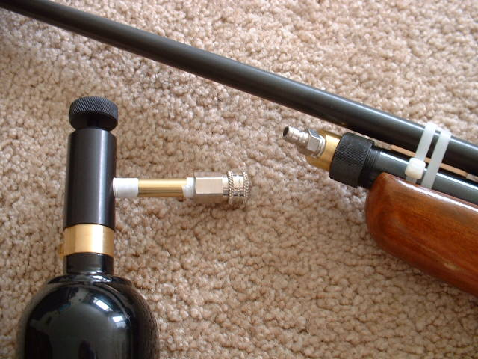
The black thing on the left is the off-on for the Pin-valve on the paintball tank. The little 1/8" copper pipe is from the hardware store.
The Quick-detach parts (like an air hose only smaller) are also from a paintball shop.
Turn the tank upside down so the fluid CO2 flows into the gun for 10 seconds
and turn it off. (or so I hear)
For $25 or $30 you can get a paintball "Remote" that has most of the parts you will need if you want to strap the tank under the rifle or carry it on your belt. The only thing you can't get at the BP store is the QB end-cap.

just found a new one in downtown Lexington, (MA) 2 miles from my house.
The guy wants $4.50 for a 14oz refill!!
I can get it for $3.50 elsewhere, but it's a 22 mile round trip (1 gal of gas=$2).
Yeah, I was thinking about talking to the city FD guys to see where I can get a CO2 fire extinguisher refilled. It would be nice to buy it for a dollar a pound (and get 15 pounds a fill) to fill the gun or smaller PB tanks from the extinguisher.
I'm just getting into this bulk stuff myself and I'm thinking about buying one of those MAC-1 extender tubes. I think it might come with a 1/8" hole in the cap that you can screw in a standard 1/8" PB fitting, Not sure.

I've got paintball stores all over the place
May 30 2004 at 11:02 PM

found a new one in downtown Lexington, (MA) 2 miles from my house.
The guy wants $4.50 for a 14oz refill!!
I can get it for $3.50 elsewhere, but it's a 22 mile round trip (1 gal of gas=$2).
Yeah, I was thinking about talking to the city FD guys to see where I can get a CO2 fire extinguisher refilled. It would be nice to buy it for a dollar a pound (and get 15 pounds a fill) to fill the gun or smaller PB tanks from the extinguisher.
I'm just getting into this bulk stuff myself and I'm thinking about buying one of those MAC-1 extender tubes. I think it might come with a 1/8" hole in the cap that you can screw in a standard 1/8" PB fitting, Not sure.

If there is liquid CO2 in that little nipple pipe, the
May 31 2004 at 10:08 Am

pop can be a real POP! when you pull the QD apart. After turning off the PB tank, I've tried holding my (warm) fingers on the high end of the pipe to see if I could boil the liquid a little,
so as to drive most of it down into the gun. Well, that didn't work real well!
I do need a bleed on that short pipe. Lowes had a shorter pipe in stock, I should have got that one!
In any event, you will loose a few shots of gas when you bleed the fill station. So, IMHO, the shorter the pipe (or hose), the better.

You're trying to bulk fill with liquid CO2, right? I just ordered the parts to do that
May 23 2004 at 3:39 PM

and was instructed that you connect the fill tank to the gun, position the gun with the barrel towards the ceiling, invert your Fill Tank, keeping it above the end cap of the gun, open up the valve on your Fill Tank, let 10 seconds or so pass, shut the valve off the fill tank, bleed the line if your set up is so equipped and remove the line...

Forgot to add, with the set up I ordered, reportedly one can expect over 70 consistent
May 23 2004 at 3:40 PM

shots with a tuned QB78 using internal bulk fill liquid CO2...

Just went down to the local paintball store and took
May 23 2004 at 4:15 PM

what they had in stock.
Nickle plated QD (male and female) $8.00
Universal tank adaptor $12.00
Brass 1/8" pipe $1.08 at Lowes.
The Chinese end-cap came from Best Airgun it was about $19 with shipping.
(2) $23 14oz CO2 tanks= $46
Darn! that's $86! Could have got a brand new QB78 for that!

I ended up getting Cooper T's setup which was a little more than what
May 23 2004 at 5:14 PM
you've got into yours...his has a flexible hose to fill with that has a check valve to bleed the line, and a bleed valve on the endcap fitting, in the event I want to dump the CO2 in the gun...
Have you tried again and gotten it to fill up good?

In addition to the good advice you've already gotten, another key to safe...
May 31 2004 at 11:24 AM

...handling of bulk CO2 is a scale. That's because the safe capacity of CO2 cylinders is rated according to the WEIGHT of the fill - not pressure, temperature, nor any other number.
Once you've got that key fact in mind, most of the other details of transfer are mainly about speed. Transfer goes faster when liquid is transferred. If gas is transferred it will condense to liquid in the container being filled anyway, but in doing so it will release heat that will slow the transfer of additional CO2.
CO2 is CO2 and there's no more difference between CO2 gas and CO2 liquid than there is between steam and liquid H2O.
Steve

