Fixing a misaligned barrel.

You will find at times that no matter how much you adjust the windage and elevation on your sights of certain guns they will not sight in. The cause of this could be barrel misalignment.
First of all you must confirm that the cause of this is barrel misalignment. This is done by looking down your barrel from the middle of the back of your rifle's stock, look down the whole top part of your air gun and if you see that the barrel is bent to one side then this is barrel misalignment and this is what is causing your gun's sighting problem.
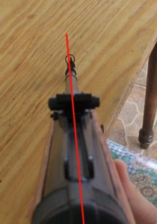
As we can see in the photo above, this air gun (XS B-4-2) has a slight misalignment to the right, in other words the barrel is bent to the right, it has been corrected by using the windage to the far right on the front slide bar windage sight. Not in all cases can the sights correct the misalignment, at times the misalignment is far too much for the sights to compensate for the misalignment. These extreme barrel misalignments can be due to improper storage, piling too many guns on top of one another, mishandling, factory error, or even shipping and handling.
There is a way that is used by gun smiths to correct this misalignment. Although this method might seem crude, it does work. I have come across a few rifles with extreme barrel misalignments and have corrected them with this method.
This method is only used on rifles that have fixed barrels. Not on break barrel air guns.
You will need the following tools, 2 strong wooden chairs and a good 3" by 4", 4 feet long piece of wood.
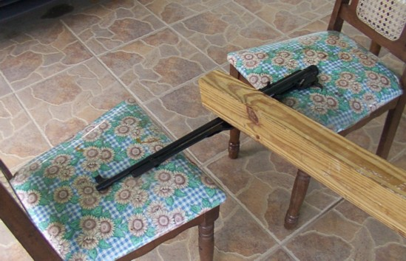
Take care and caution when doing this, if you use to much strength in your blow to the air gun you could damage or ruin the air gun.
Notice I have taken off the stock and have placed the air gun on the side that the middle is bent upwards looking up, in-between the chairs. I then take the piece of 3"x4" and take aim at the middle of the air gun where the barrel is inserted. The idea here is to whack the upward bent part down to the proper level to straighten the barrel and the rifle to a better alignment. This piece of wood is rather heavy, very little strength is used to give the blow on the bent part, the weight and speed is enough most of the time to bend it straight. Using light strength, carefully whack the air gun, check the alignment to see if it has improved. If not, use a little more strength and whack it again until you see that the barrel and the rifle are aligned in a straight line. When carefully done the repair is unnoticeable and the wood does not mark the bluing or metal.
After you are sure it is aligned in a straight line, sight in your air gun again.

