
Revised 3/17/13
Installing the GRT-III trigger blade

WARNING WARNING WARNING WARNING
Take care to remove the correct pivot pin in the trigger…see the instructions

Read these instructions CAREFULLY AND ENTIRELY before proceeding.

(Be sure to read all notes including the safety note and disclaimer at the end of the instructions)

Crossman Quest and B-18/19 customers see the last page

There is an installation pictorial on my website. http://charliedatuna.com/airgun_docs/GRT%20III%20Trigger.pdf
Also a Word File print out here: http://charliedatuna.com/airgun_docs/GRT-III%20trigger%20blade%20instructions.doc

Installing the GRT-III trigger blade is a relatively simple procedure and in most cases does not require removing the trigger from the gun. The whole process can usually be done in ten minutes or less. The only tool required is a screwdriver suitable for the fasteners on your gun (usually just a simple Philip’s head of the right size), or a #25 Torx screw driver and a small standard head screwdriver in most cases.

Be aware that the Glide and/or Roller may fall out when you remove the stock

There is a little U shaped part that fits/sets on the cocking linkage and that is the glide (not guide). It prevents metal to metal contact between the action and cocking linkage when cocking the gun. With the action and linkage facing up and the barrel facing to the right, it fits into the notch on the bottom of the cocking linkage between the action and the linkage. There are two notches in the linkage. With the barrel facing to you right, it goes in the notch closest to the barrel with the narrow part of the glide facing you as you install it.
The roller goes on the pin on the side of the cocking linkage. There is also a small washer spacer that sets on the pin also. The washer goes on first, then the roller.

The trigger blade consists of four pieces, the trigger blade, the 1st stage adjustment screw, the 2nd stage adjusting screw the 2nd stage adjusting screw tension spring. These parts are already assembled for you as well as pre-adjusted.

It is not usually necessary to remove the trigger assembly from the gun to install the mod but is shown here for better visual understanding. The right half of the picture depicts what the original trigger blade looks like when removed with the parts shown directly under where they go, and the left side depicts the trigger blade and mod parts and where they are located. The trigger return spring and its retaining pin and original adjustment screw are not reinstalled for the modification, but be sure to save for later use if desired.

Below are pics and illustrations showing the trigger and some of its parts pertaining to the mod.

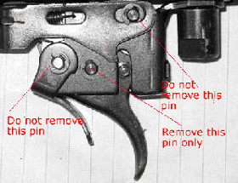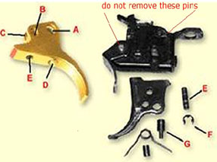

Here are the steps for installation for Springer’s – (some Rapids will be a bit more complicated).

1- Make sure that the gun is un-cocked and unloaded! Safety first. Always!

2- Remove the stock by removing 2 forearm stock screws and the rear screw in the trigger housing. Be aware of the small plastic glide (u-shaped) in the notch under the cocking linkage and roller(s) on the side cocking arm linkage. They may fall off while removing the stock. Note: Gamo CFX and some late model Gamo synthetic stock gun owners see note at the end.

3- Remove one of the e-clips (F) from the trigger pivot pin (E in right picture) for the trigger blade. It doesn’t matter from which side the e-clip is removed and some have only one on one side. (This may not be possible in the Rapid PCP without actual removal of the trigger assembly from the action.)

4- Remove only the trigger pivot pin. (E) in the right picture. DO NOT REMOVE the pins going through the safety lever or link.
5- Slide the trigger blade out of the trigger housing.

6- Remove the Fat Trigger pin (G) from the trigger blade. Notice that the smaller diameter of the pin, (pin extension), rides in the slot. This slot is referred to as the bear trap pin slot.

7-Remove the small original adjustment screw that sets inside the rear of the trigger housing.

Put the old trigger blade, return spring, the spring retaining pin and the adjustment screw in a safe place so they will be available in the future in the event you would want to reinstall the stock trigger blade although I doubt you would ever want to do that.

Note to Rapid gun owners:
In some Rapids, the trigger group must be removed to remove the trigger pivot pin to install the GRT.

Note: Now would be a good time to lube/service your trigger, while you have the trigger blade out. The best lube to use would be a moly and 30wt non-detergent motor oil mixture (1 part moly and 5 parts oil), but most persons won’t have the moly available. If not, just use 30wt non-detergent oil. Drop just a drop each onto all springs and pivot points and on the lever that makes contact with the new trigger blade. Also lube the Fat Pin and the Pivot Pin as you install them.
Installation: Installing is easy as you can see in the diagram. First lube the trigger pin holes and adjustment screw tips in your new trigger. Install the Fat Pin (G) into the large hole (A) of the new trigger blade so that it is facing in the right direction. The smaller diameter side of the pin goes to the side with the slot in the trigger housing.
Note: check fat pin slot for sharp corner as well as sharp stamping edges along the edge of the trigger housing along the side where the trigger travels.
1- Slide the new trigger blade up into the housing with the fat pin extension going up into its slot, line up the pivot pin and trigger blade hole (B) and install the trigger pivot pin (E) in the right picture. Be sure as you slide the trigger blade up and into position that the lever, the long piece of metal above the trigger blade, is riding in the slot (C) on the top of the trigger blade and not riding up on the edge of it. If it is, simply slide it over until it drops into the slot with your small screwdriver as the trigger blade and pivot pin is installed. If it is not properly installed, the gun will not cock when assembled.
After the trigger is installed, check the edge of the trigger housing where the fat pin slot is. Quite often it is bent inward just a little on the corner/edge of the slot when it is stamped out during the manufacturing of the trigger housing at the factory causing the trigger to catch or drag on it. When the trigger is installed, the trigger will catch and drag on the bent in sharp edge if not filed down flush. This is soft metal and that sharp edge corner is easily filed down if needed. Quite often I find the bottom inner edge of the trigger housing has sharp edges and I remove them also.
2- After installing the new trigger blade, you can look into the fat pin slot on the side of the trigger housing and see if the lever is in place. If not, just slide it over until it drops into the slot with your little screwdriver. The lever must be in the slot (C) when you finish the installation. As stated above If it is not properly installed, the gun will not cock when assembled.
3- Reinstall the pivot pin e-clip that you removed and reinstall the stock. That’s all there is to the installation.
The parts shown below are not used and when installation is complete.
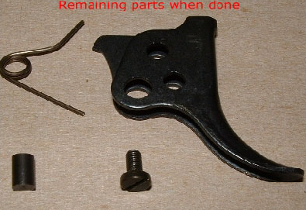
Note: The trigger blade has been pre-adjusted and it should be pretty close for most application. Just install it and adjust only if necessary. If by chance you have back and forth (fore and aft) sloppy free play in the trigger, adjust the first stage screw in to remove the free play then add 1/8 turn. You may then need to slightly adjust the second stage.
IMPORTANT…CHECK THIS

With the stock still removed, break the barrel a few inches.

Pay particular attention to the area where the Fat Pin moves past the bear trap link tab. (The bear trap link is the long thin slotted metal part that goes from the cocking arm to the trigger).The tab at the top of the bear trap linkage should pass under the fat pin shoulder.

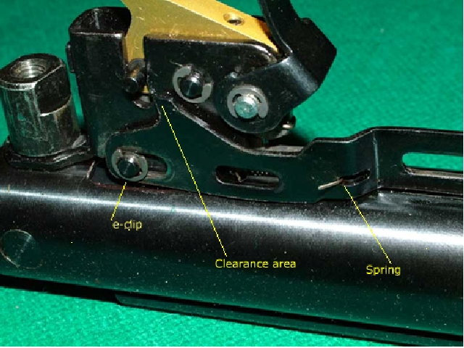
It should clear the tab without hitting it. It will be pretty easy to see where it makes contact on the link tab.
If that is the problem, just remove the e-clip holding the link but DO NOT REMOVE PIN. There is a small spring that retracts the bear trap link attached to the back side of the bear trap link that you will need to disconnect from the link. (Just remember to reattach it when you are done).Raise the link up and file the corner enough to clear it. It won’t take much to file off just a few thousandths of an inch or just enough for clearance Check it again with the little link return spring installed to be sure that you have the necessary clearance. If all is ok, close the barrel back up to battery.

Now move the trigger back and forth its full travel length to be sure that there is no other interference with the bear trap linkage and the fat pin shoulder.
If for some reason you have an installation problem, go here…
http://charliedatuna.com/airgun_docs/GRT_III%20Troubleshooting.doc
IF YOU MUST………Adjusting your new trigger:
When making adjustments be sure that the Allen key is inserted all of the way into the 1st stage screw.
Adjusting your GRT-III may at first seem complicated, but it’s actually quite simple. I go into depth here so that you understand what you are doing as well as how to do it.
Note: The GRT has two points of adjustments: 1st (E) and 2nd (D) stages. The 1st stage adjustment is located in the forward part of the blade near the safety, and the adjustment will have a 4-48 Allen hex screw (the Allen hex tool .050 is provided) and the 2nd stage will be a 4-48 standard screwdriver slotted screw.
Adjusting the first stage:
The 1st has been preset to accommodate most trigger internal dimensions. You probably don’t need to touch it and I suggest that you do not change it. Proper adjustment of the 1st stage is necessary to avoid two things:
- If the 1st stage screw (E) in the left picture is turned too far in (clockwise), then the safety toggle won’t work and the safety will not lock properly.
- If the 1st stage screw (E) in the left picture is turned too far out (counter-clockwise), then the trigger blade will have too much forward travel and will have excessive free play.
Any setting of the 1st stage screw between these extremes is satisfactory and safe. If your trigger exhibits neither of these problems, then the 1st stage adjustment is okay. Otherwise, adjust it slowly (turning “out” if the safety won’t fully engage, turning “in” until the free play is removed) but not to the point that the safety will no longer engages and holds. That’s pretty much it for the 1st stage.
Adjusting the second stage:
The 2nd stage adjustment screw is located in the trigger blade at point (D) and is the primary GRT adjustment. Counterclockwise adjustment of the screw shortens the 2nd stage (reduces creep), clockwise lengthens it (increases creep).
Using your small flat blade screwdriver such as a pocket screwdriver turn the screw in clockwise or counter clockwise to adjust. Move the screw in very, very small increments. Remember, there is 3/4 turn or a little less of true span adjustment so it’s easy to move out of the adjustment span and you will then need to “hunt” for it. Adjust the 2nd stage if necessary to suit you.
Adjustment summary:
1- Check the adjustment of the 1st stage for proper safety engagement and removal of slack.
2- Adjust the 2nd stage for the desired feel.
That’s all there is to it and it takes just a few minutes to do.
Help....I can’t find the 2nd stage adjustment:
Keep in mind that the second stage is not a hard stop but rather a slight change in resistance and more of a roll over much like many match triggers. Depending on the trigger and the internal springs, the feel will be more predominant in some guns and lighter in others. This cannot be changed without modifying the internal trigger springs and that is not recommended.
If you are unable to locate the 2nd stage adjustment, remove the trigger blade and using your adjusting tool, adjust the second stage screw to a point where you have between 4 and 5 threads showing in the lever slot and that will put you real close, then reinstall the blade. You should now be within ½ turn or less one way or the other of the adjustment span. When you are moving “pulling” the trigger and you will feel a very slight change in resistance. It’s at this point where you are at the 2nd stage adjustment span. Set the adjustment to about the center of the 2nd stage. This will be acceptable for most shooters.
Re-install the stock. Now (with the gun still unloaded and un-cocked) try pulling the trigger while paying attention to the feel. Now you are ready for the final adjustment if desired.
The final adjustment is a matter of taste and is done after cocking and firing the gun while using the usual safety practices. After you have fired the gun to test the trigger, you can make slight adjustments and test it again. Be careful on your first few shots, as the trigger will feel and be totally different than what you are accustomed to. Always observe basic safety rules.
Remember these two important things…….
1st Stage) Screwing in the first stage screw beyond taking out the initial trigger free play (slack) can compromise the safety toggle lever engagement. The deeper you go (the less 1st stage travel) the less room for the toggle to block the trigger.
2nd Stage) Screwing the adjustment screw in (clockwise) will lengthen the second stage while backing it out will shorten it. It is important to make this adjustment in very small increments – 1/16 of a turn or less at a time. It is possible to adjustment the screw either way to a point where you have no 2nd stage at all.
Although doing this does no harm to the gun nor does it make the trigger unsafe, it does defeat the purpose of a two stage trigger, so do not set it so close that the gun will fire before it reaches the second stage. I suggest that, at least to start, you leave yourself some pull room, (creep), in the second stage so you will be able to easily pre-determine when it will fire. You may find that, after getting thoroughly familiar with the feel of your GRT, that you’ll become comfortable with a lighter 2nd stage pull
Note: You must be careful because you can also run the adjustment screw in so deep that the gun may not cock or may misfire.
Safety Notes! Safety Notes! Safety Notes!
The Safety..With the GRT-III, the trigger will have lock out but in some cases you can, with effort, pull the trigger through the safety. This is especially true if the trigger is incorrectly adjusted to a shorter first stage (see: Adjusting First Stage above), You should be aware of this.
Important Safety note regarding balked fires:
If you start to pull the trigger, but then release it without firing, the sear will not reset to its original (as-cocked) state automatically. This may leave your rifle on the verge of firing and therefore in an unsafe condition where the slightest jolt or vibration might cause a misfire. Therefore, if you begin to take a shot, but then change your mind after having already started to pull the trigger, it is important to always re-cock the gun to reset the sear.
The non-resetting sear is not a side effect of the GRT-III trigger blade modification. but . You probably never noticed it before only because the blade return spring of the unmodified trigger creates the illusion of automatic reset when the trigger blade is released. A partial pull-through has always had this potential for leaving the sear in a state of partial disengagement. Always re-cock a gun whenever a trigger is even touched without actual firing on any gun.

Gamo CFX and some late model synthetic stock rifles stock removal
The Gamo CFX and some of the other late model guns with synthetic stocks have the forestock retaining screws covered by the rubber hand pads/grips located on each side of the forestock. These pads must be removed to get to the screws. Insert a small blade screw driver or something similar under the rear center of the pad/grip and carefully lift enough to get your fingers under enough to pop it off. To reinstall them, just press them back in. Remove the screws that are used in most CFX’s (and some other Gamo’s) with a #25 Torx screwdriver.
NOTE: If you encounter a trigger installation problem, go here for the trouble shooting guide.
http://charliedatuna.com/airgun_docs/GRT_III%20Troubleshooting.doc
Bob aka: CharlieDaTuna
e-mail: CDT22@Frontier.com
website: http://charliedatuna.com/
Gateway to Airguns Forum: http://www.gatewaytoairguns.org

