Glide and Roller

There is a little U shaped part that fits/sets on the cocking linkage and that is the glide (not guide). It prevents metal to metal contact between the action and cocking linkage when cocking the gun. With the action and linkage facing up and the barrel facing to the right, it fits into the notch on the bottom of the cocking linkage between the action and the linkage. There are usually two notches (some of the Chinese clones have only one) in the linkage. (See the pic below) With the barrel facing to your right, it goes in the notch closest to the barrel (furthest from the roller) with the narrow part (if there is one) of the glide facing you as you install it.

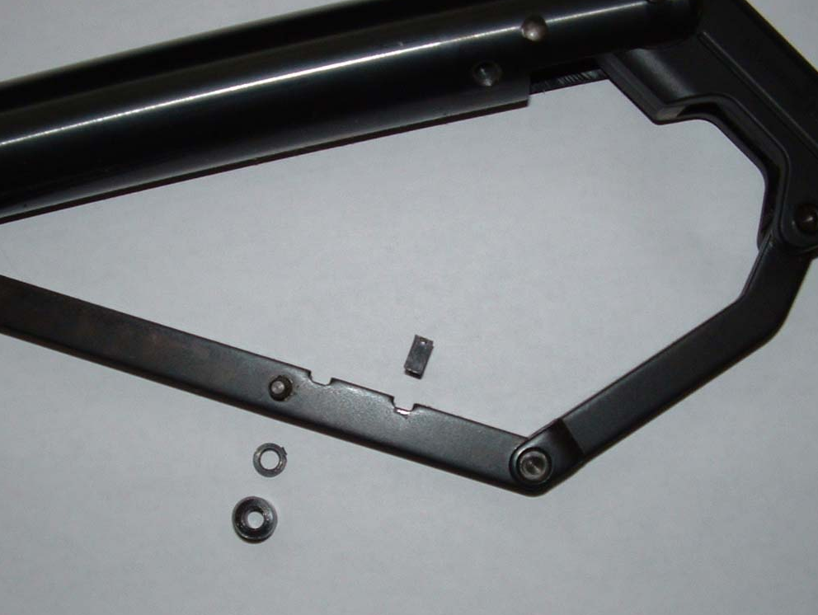

The roller goes on the pin on the side of the cocking linkage. There is also a small washer spacer that sets on the pin also. The washer goes on first, then the roller.

