Hand Lapping Your Airgun Bore Tutorial
By Scott Laughlin

Hand lapping offers some advantages over fire lapping. Since a well cast lap fills the bore, the chance of rounding or reducing the depth of the rifling is greatly reduced. A lap can only increase the bore diameter to the size of the largest section, (since you can only bump up the lap to that (largest) diameter) so worries about creating an oversize bore are greatly reduced. You can feel your progress, tight spots can be worked out, and a slight choke can be created at the muzzle. In general, it’s a more finely controlled process than fire lapping. As always...this is for informational purposes only, YMMV, don’t blame me if you mess up.
To effectively hand lap an airgun bore, you need a cast lap that exactly duplicates the bore of your gun, a rigid rod that you can cast a lap on, and a ball bearing handle for the rod. This will allow easy rotation with the rifling under the loads created as you stroke the loaded lap down the bore. You will need easy access to the breach of the barrel. DO NOT lap from the muzzle, too much chance of damage to that critical portion of the bore. Also lapping compound, (we’ve talked about that in the previous segment) a “bump up” rod. (a length of uncoated brazing rod that fits your bore as close as you can manage), and something to tap the bump up rod with such as a tack hammer or short length of metal bar. Also you will need a little bit of lead, old pellets will do, and a way to melt and pour them accurately.
I’d recommend doing at least a couple practice barrels before you attack your favorite gun. Find a beater .22 rimfire at a gun show or perhaps buy a .22 and a .177 barrel from Crosman, pick up a Cummins Chinese gun or whatever. I suggest doing a .22 first, because for practice purposes its lots easier to get a good cast in the bigger bore than in .177.
Push a few pellets thru the bore, feeling for tight spots, and mark those spots. If the last inch of muzzle is much looser than most other spots, there’s relay not much you can do. A lap has to be cast near the muzzle, and will jam before you get very far. Cutting off the loose spot is about your only option. You can try to fire lap, but you’ll have to remove so much from the rest of the bore that you run the risk of damage.
Some way to securely hold the barrel is very important as you are going to push and pull pretty hard on it. One good way is to take a couple 8” lengths of 1x2, clamp them together with a piece of manila folder between them. Now drill a hole the size of your barrel, or a slightly smaller down the joint. Cross drill for wallboard screws in about 6 spots, and unclamp. Pull out the paper, dust the grooves with rosin (weight lifters rosin bag) and screw one block at about hip high to a solid workbench or doorframe, groove level. Put the barrel in the groove, screw down the other block.
For the handle, you can try a store bought swivel, or “ball bearing” cleaning rods, but I find they don’t rotate easily and often fail. I use bike quick release hubs (any bike shop will have a few laying around and they’ll sell them to you cheap) from which I’ve cut away the flanges and then ground smooth. I rebuild the bearings, set them up just a bit loose and lube with a light grease or heavy oil. I assemble them with the hub near one end of the axle to leave a longer stub at one end. I thread on a standard nut (sometimes called a “city nut” or “anti-theft nut”, LocTite it, then drill and tap it for the setscrew used to grab the lapping rod.
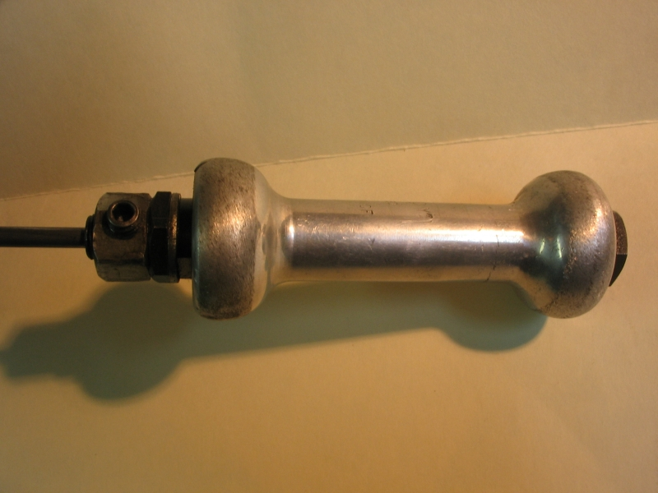

The rod needs to be rigid and straight, and stay that way. The best solution I’ve found is piano wire in larger sizes, far more rigid than most cleaning rods.
To prep the rod to receive the lap, you need to grind or turn it down to about ½ bore diameter and groove it to help it retain the lap. Reduce and groove about 1” of rod (or a long set screw if using CF rod)
Your ladle can be a rough spoon hammered out of some sheet steel, an old serving spoon with a notch filed in one edge, something that will hold about 10 pellets worth of lead. You’ll need a propane torch to melt the lead, a dab of beeswax or soldering flux (rosin type) to clean the lead. It would be best to melt and pour outdoors, but at least get good air circulation, and move anything burnable away.
Disassemble the gun enough to allow easy access to the breach. With barrel cockers, remove the barrel from the gun, with side and under levers, pump and co2 guns, you’ll have to work through the receiver. (Make sure your rod is long enough) Cut your bump up rod to just a couple inches longer than your bore, and square the end. If you are doing a Benji or similar, cut a few lengths of plastic straw and split them down one side, these will protect your receiver. Clamp the barrel at about 80deg; you want to pour the molten lead at a bit of an angle. Wrap the rod with several turns of Teflon pipe tape or glide dental floss, about an inch below the reduced and grooved section at the tip. Get an easy slip fit in the bore, just tight enough to hold the rod where you put it (no handle yet).
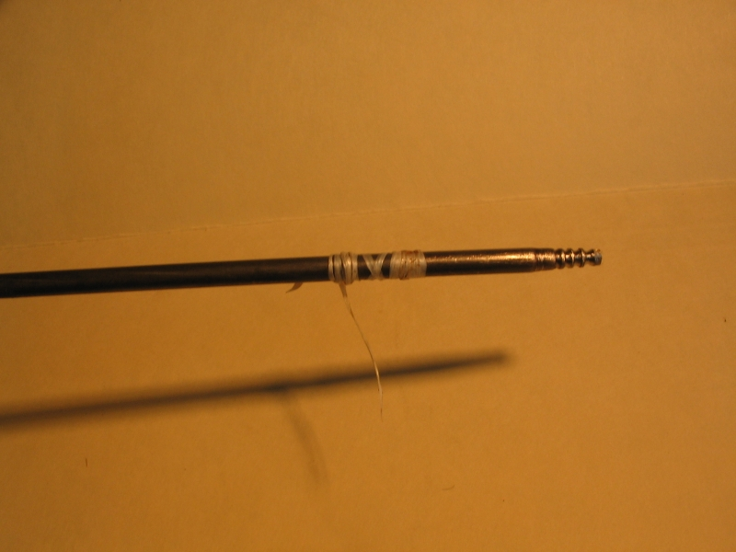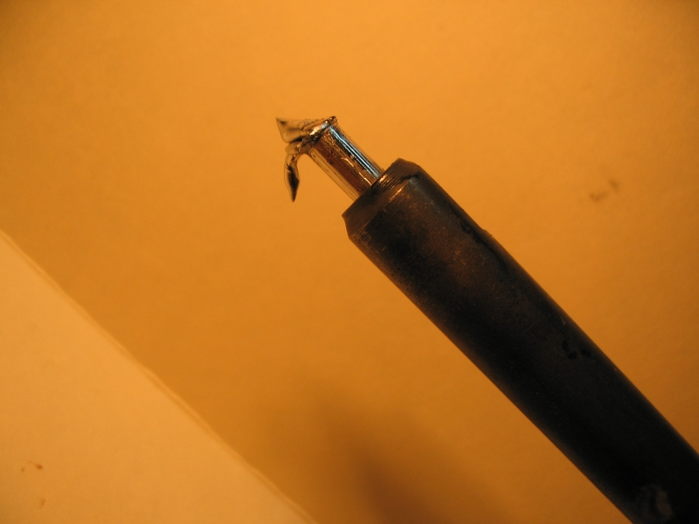

To cast in a .177 bore you will probably have to heat the muzzle some. I find a crayon mark melts at about the right temp. In .22 you probably can cast in a cold or just warm bore. Once the barrel is warm/hot, with the tip of the rod just showing, melt the lead (while keeping the muzzle warm, a helper is nice) When lead is ready, pull the rod down about ½”-1” and pour. (careful of your feet and anything else on the floor or bench top) Fill the bore to the muzzle. Give the lead a minute or so to set, and tap the other end of your rod to bring the lap about ½” out the muzzle. You should see a perfect cast of the bore, rifling sharp and clean. If not try again.
When you get a good cast, trim the end square just below the flare left by the crown, and file a couple shallow grooves around the lap with a triangle file. Put a couple drops of oil on the lap, and attach your handle. CAREFULLY pull the rod back until you see the Teflon on the rod. (You should see the rod rotate as you do so). Arrange some sort of back stop or lanyard to help keep you from pulling the lap fully out of the bore. If the lap ever leaves the bore completely, you need to cast a new one. Run the lap back out the muzzle ‘till the grooves show, and rub a dab of lapping compound into the grooves. Pull it back into the bore about 1”, then reset your handle against the breach or receiver end as a forward stop. A faucet washer slipped on the rod makes a good bumper. (by not working in the last inch of bore, you end up with a slight choke)
Now the work starts...As you run the lap back and forth thru the bore, you feel areas of resistance, probably in the areas you noticed with your pushed pellets. Concentrate on these spots until they loosen up. When the lap runs pretty easily, find a loose spot, slide your bump up rod down the bore to touch the end of the lap, and tap the end of the bump rod once. The lap should feel tight in the bore again. Repeat this process, adding a drop of oil at the muzzle on occasion, until the rod feels the same in all parts of the bore. Early in this process at times when the lap has loosened and just before bumping up, let it run out to the muzzle, and out to the throat of the breech. Don’t let the lap come out of the bore, ever. Don’t let the rod rub in the bore or receiver; wipe off any compound you see on the rod. NOTE: If you haven’t got a bore that feels good by about 100 strokes, it’s a good idea to cast a new lap. The old one will be worn, and you risk rounding the edges of the lands.
When you have a bore that feels even, (or you just run out of patience) stop. Remember, you don’t have to get it perfect this time, you can repeat the process at another time. Clean the bore, breach, etc carefully; you don’t want lapping compound in the guts of your gun. Reassemble the gun, and test. I’d recommend using lubed pellets from the first, or treating the bore, it’s as clean as it’s ever going to be.
I’ve found that lapped bores tend to be less pellet fussy (if not oversize to start with) more accurate, and need less cleaning. Try a few and let me know how it works for you...
Scott Laughlin

