Introduction to Adult Airgunning
David Geesaman, ed. Lou Calkins

Many people, myself included, grew up with a Daisy, Marksman, or Crosman BB gun. The lucky ones had a Benjamin/Sheridan pumper. Most of us left these behind as relics of our childhood. My introduction to adult airguns was as a kid reading the specs on RWS Dianas in a Cabela's catalog: ‘Wow! 1000 feet per second?! .22 Caliber! Who needs gunpowder?’, I thought. The hook was set, and now some years later I find how much is readily available via the Internet. Since I didn't know any local airgunners, I learned this information slowly on my own from many different sources. My hope is to help introduce the basic information to get an interested beginner started with minimal time and effort.

Adult Airguns are a much bigger subject than most Americans are aware of. These guns shoot lead pellets in .177, .20, .22, and .25 caliber, and a few shoot .308 and .50 caliber at speeds right up to the sound barrier (1150 fps). They are used for target competition, small game hunting and pest control, and of course for fun backyard shooting. Adult airguns will cost anywhere from $100 to $1500, not including accessories. Adult Airguns are a significant step up from the best airguns stocked in sporting goods stores, are made of high quality materials equivalent to fine firearms, and can last for decades. They can be used safely and quietly in populated areas where a firearm is not acceptable. The goal of this article is to guide the new airgunner through the blinding array of information to choose the right kind of airgun. I will talk about safety precautions, sights, accessories, ammo, and will give an introduction to more advanced information. This article will focus on airguns used in standard calibers for hunting, plinking, and pest control.

What to expect:
In an Adult Airgun, you will find:
• Usually single shot, but a few multi-shot models which load a pellet as part of the cocking action.
• Powered by compressed air, compressed CO₂, or a spring-driven piston. Some compressed air models can be powered for each shot by repeated pumps (a 'pumper'), and others have air held in a tank that is filled in advance.
• Effective range from 10 to 75 yards, depending on the airgun and shooter.
• Low operating cost. Once purchased, even premium quality pellets cost less than $.05/each.
• Muzzle velocities from 500 fps (for target and casual shooting) to 1000 fps (for hunting).
• Accuracy from a top-quality airgun in ideal conditions can put repeated shots through one pellet hole at 10 meters, or ½” to 1” groups at 50-75 yards. With a little practice, the casual shooter can usually be deadly on small game out to 30y.
• The energy of the pellet is generally more important than raw velocity, especially for hunting and pest control. Energy is a product of the pellet weight and velocity and is expressed in foot pounds of energy (fpe). In many cases, using a heavier pellet will provide more energy causing it to fly better over long distances because of it's resistance to drag and wind. Energy generally ranges from 5 fpe to 40 fpe.
• Greater adjustment for drop and wind effects. In competitive shooting, airguns require more judgment from the shooter when compared to firearms. That’s what makes competition so gratifying!
• Open, Peep, or Scoped sights. For spring-powered airguns, an extra-durable scope and special airgun scope mounts are required. Very few firearm scopes will survive the sharp forward recoil generated by a “springer”. Even the best firearm gunsmiths will probably not have the information required to equip your airgun with a proper scope, nor will they understand this issue. Most airgun scopes have an adjustable objective (AO). An AO scope adjusts focus, corrects for parallax, and can be used to determine range. This importance of an AO scope may be new to firearm shooters who are accustomed to shooting at longer ranges where this type of error is diminished.
• Pellets come in many types, and experimentation is the best way to determine the most accurate and/or powerful pellet for a particular gun. Blindly buying the most expensive pellets usually doesn't work, and you will likely also need to purchase these pellets from an airgunning shop.
• Indoor and backyard shooting is practical with the right safety precautions. Many shooters buy a heavy-duty pellet trap or make their own. Traps designed for consumer BB guns will probably not last long with the increased energies of adult airguns. Airguns are an excellent way to introduce kids to fundamental shooting techniques and safe gun handling necessary for firearms. On the opposite end, firearm shooters have found airguns to be outstanding practice for their firearm events.
• Expect to get hooked! Shooting airguns is cheap, accessible, quiet, clean, accurate and challenging. There are numerous stories of people who reluctantly take their first shot and don’t stop until they’ve emptied an entire tin of pellets.

Specifications and Design:
It's very important to know what type of airgun is best for your needs. In fact, there are so many models available that a buyer almost needs to decide on each specification to narrow the choices to an acceptable list. In general, airguns are versatile. But for a beginning shooter, it's vital to find the right gun for your budget and practice constraints. Some of the key specifications to consider are cost, caliber, power (velocity), powerplant type, stock design, trigger, and sights.

Pistol or Rifle is the first choice. Pistols generally do not have power and field accuracy suitable for hunting and pest control, but competition and plinking is great fun with pistols. Rifles are bigger and more expensive, but are available with considerably more power, range, accuracy, and forgiveness to the shooter.

Caliber choice is a very common question. .177 is the most common and is the caliber of choice for Field Target and competitive Match shooting. Other available calibers include .20, .22, and .25. Smaller calibers will achieve higher velocity and have a flatter trajectory in most cases, but will lose energy more quickly than larger calibers. For hunting, many shooters prefer the power of .25 but it requires good shooting to handle the extra pellet drop at longer ranges. .177 pellets are cheapest and most plentiful, with .22 not far behind. A few custom gunmakers even make super-powerful .25 to .50 caliber airguns, if you've got the wallet for it. All that said, it's up to you - a powerful .177 can still do well at hunting and an accurate .22 can shoot impressively on paper targets.

Power is often misrepresented. Manufacturers publish velocity numbers, but what they don't tell you is that:
1) shooting a pellet beyond 1050 fps can cause it to become unstable and quickly lose accuracy and velocity.
2) they are testing much lighter pellets than you will use, and
3) this velocity is not necessarily an average value of all the guns produced.

Arguably, the more important parameter is Energy. Calculated from the pellet velocity and pellet weight, it describes the hitting power of the projectile. It is the regulating measurement for airgun power in many countries. (i.e. in the UK, 12+ fpe airguns require a Fire Arm Certificate.) Energy is useful because it allows a fair comparison of pellets of different weights. Therefore, be wary of any velocity number that is mentioned without the exact type of pellet or its weight.

Powerplants are available in 3 major types: pumped pneumatic, spring-piston, and pre-charged pneumatic (PCP) / CO₂. The power, accuracy, and expense of these types roughly follows the same order.

1. Pumped Pneumatic airguns are a good choice for a beginner’s airgun, and they remain popular for their low cocking effort, availability, and low cost. Repeated cocking increases pressure by pumping air into a small reservoir. Pulling the trigger releases the air directly behind the pellet. In some cases, they can be modified to handle significantly greater power. The accuracy is good, but is bettered by higher quality, more powerful guns. Popular brands include Benjamin Sheridan, Crosman, Daisy, and Marksman. They are also easy on scoped sights, and work well with low-priced rimfire and airgun scopes.

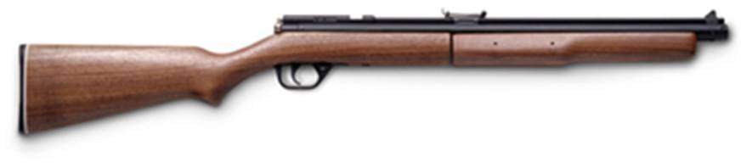
Benjamin-Sheridan 392 Multi-pump Pneumatic

2. Spring Piston airguns fill the midrange, and represent a great compromise of simplicity (one cock operation, no accessories needed) and power. The spring is generally a steel coil spring contained in the tube above the trigger. Cocking the gun compresses the spring with its piston, but does not compress any air. The cocking action can be done using the barrel as the lever (a break-barrel), using a lever that folds along underneath the barrel (underlever), or using a lever that lays flat alongside the action (side lever). Although most shooters will not see a visible difference, the underlever and side levers can be slightly more accurate because the barrel is not moved during cocking. Break barrels offer a longer cocking lever and a simple mechanism, which accounts for their use in the higher powered spring guns. When the trigger is released, the spring releases and drives a piston through the air chamber behind the pellet. In an instant, the air is compressed and the pellet is gone. Unfortunately, the pellet has not left the barrel before the recoil of the piston is felt, requiring the shooter to hold their aim through the recoil and not allow their reflexes to alter their hold of the gun. The recoil is not as strong as a firearm, but it will affect accuracy if the shooter is not practiced to handle it. Learning to shoot a springer well will improve the skills of any firearm shooter. Most springers have a characteristic 'twang' sound from the spring vibration, although tuning can reduce or eliminate this. Also note that the action of the piston reaching the end of the chamber causes reverse recoil that damages most firearm scopes, so scope selection is critical for this type of gun.

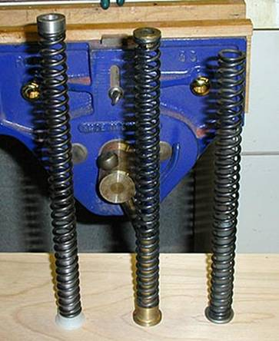

Aftermarket (left, center) and Factory (right)
Mainsprings and Guides
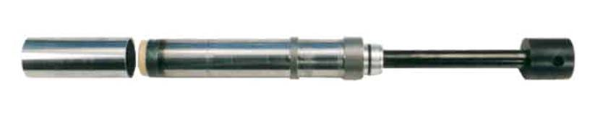
Theoben HE Gas Ram system

Gas springs (Gas Rams) are a relatively new type of spring – they have no twang, and can provide superb power. The downside is usually expense and increased cocking effort. Some manufacturers claim gas pistons are faster (shorter lock time), thus affecting the pellet less from recoil, but independent tests have not found a significant difference over coil springs.

1. Pre-charged pneumatic (PCP) and CO₂ airguns work just like pumped pneumatics, except there is a multiple-shot source of compressed gas either within the gun or attached to it. In most pistols and rifles, you will see the reservoir tank in the form of a cylinder (long or stout) attached underneath the barrel. CO₂ was once the bulk gas of choice, but with the proliferation of SCUBA equipment, compressed air is now the standard. Compressed air has the performance advantage over CO₂ because of better consistency in varying ambient temperatures, and low cost since SCUBA shops can compress their own air with the right compressor. CO₂ offers lower equipment cost up-front, convenient recharging (just change to a new cylinder), and does not require trips to the local dive shop (or the not-so-local dive shop, as the case may be). The gun reservoir can be filled by using either a special hand pump (cheap, but good exercise), or a SCUBA tank. PCP and CO₂ airguns require a single cock per shot. This is a quick and easy step to reset the valve spring. The accuracy and power available with a PCP bests the pumpers and springers with ease, although the cost is higher and a source of compressed air must be obtained. A relatively new advancement is the carbon-fiber bulk tank. These tanks are much more portable than traditional SCUBA equipment. The advantages of PCP airguns have addicted enough spring-piston owners to have earned them the nickname of the 'dark side'. The recoil of PCPs reflects the behavior of firearms, providing more options for purchase of scoped sights. Nearly all open competitions and matches are now won with PCP equipment.
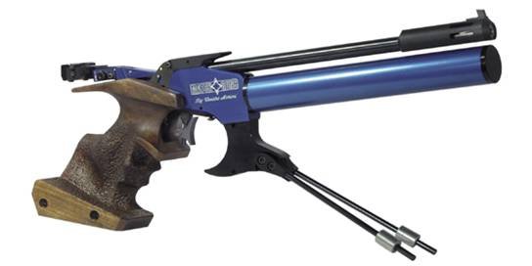
Match Gun MG1 PCP Target Pistol
(PCP reservoir is the blue tube)

The design of the gun stock (or handles, in the case of a pistol) is important to performance because a good stock that fits the shooter well will help the shooter support, balance, and aim the gun consistently. Better stocks will have more durable finishes and are carved into more intricate ergonomic shapes. Competition gun stocks even have mechanical parts that adjust the dimensions of the contact points to fit any shooter.

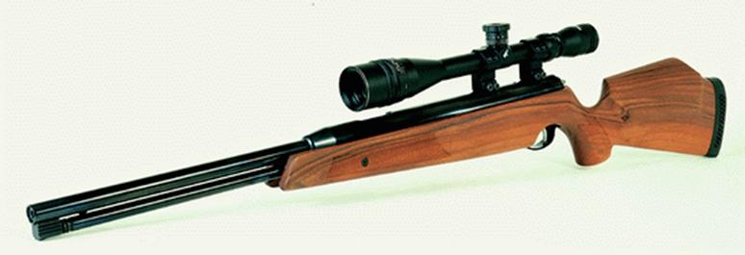
Sporter stock and scope on an Air Arms TX-200 Rifle

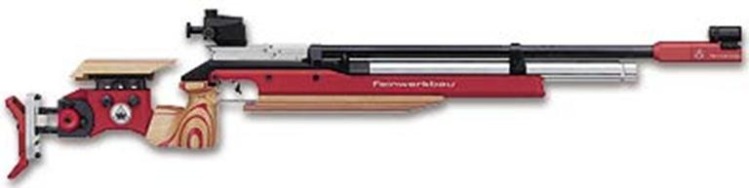
Adjustable stock and peep sights on a Feinwerkbau P70 PCP Target Rifle

Shooting with a good airgun trigger offers quite a different experience when compared to a firearm trigger. First, airgun triggers are 2-stage, meaning the shooter feels the trigger pull through two stages of resistance before firing. Second, airgun triggers usually have a lower pull weight than firearms, and firearm shooters should be careful to avoid accidentally discharging the gun. Target shooters prefer very light trigger pull weights because the act of pulling a light trigger will have less disturbance on their hold of the bullseye. Hunters and casual shooters are safer using a trigger with a greater pull weight. Triggers are often refined by polishing the internal parts to smooth the sliding actions, or tweaking the adjustment screws to change its feel. BE CAREFUL and do a little homework first. If screws are adjusted, never change them more than 1/4 turn at a time. If adjusted incorrectly or improperly lubricated, the gun may not cock or it may dangerously misfire if bumped. If in doubt, have an airgun professional make the adjustments.

Sights can be laser dot, open sights, optical scopes, or peep sights. Peep sights are used mostly for target shooting since the shooter can only see a very small portion of the target at once. It is the sight of choice in competitions that outlaw magnifying optics. Laser dots are becoming popular for their simplicity and low cost. Open sights are included on most guns, and can provide sufficient accuracy for a surprising range of uses. Finally, scopes are the choice for both short and long-range accuracy. The best airgun scopes have adjustable objectives to permit precise aiming as close as 8 yards all the way out to 50 yards and beyond. The important thing is to choose the right size and features in a scope, and to mount and adjust it correctly. Higher magnification scopes are larger, heavier (affecting gun balance and portability), more sensitive to adjustment and eye position, and much more expensive. Most experienced airgunners would suggest erring on the side of extra quality in a scope instead of additional size/magnification. Note: many break-barrel springers shoot a trajectory slightly downward relative to the scope rail (a.k.a. ‘droopers’), so consider an adjustable mount or a mount specially set up for such ‘droopers’.

Any sight will require you, the shooter, to practice shooting at all of your intended distances to learn the amount of pellet drop (holdover) before competing or aiming at game. There are many great articles on scope adjustment and mounting, so I won't cover that here. But if you intend to put a scope on your airgun, plan to buy a special scope and mounts.

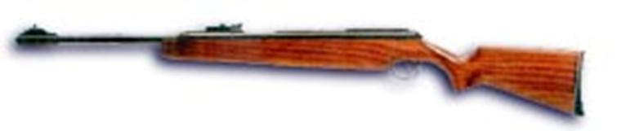
Blade sight on an RWS/Diana Model 48

Moderators, Muzzle Brakes, and Silencers can be made both integral to the gun and available separately. In the US, if you use a silencer that is removable or interchangeable with a firearm, it must be licensed, even if only used on an airgun. If the moderator/silencer is built into the gun barrel, US airgunners have not been required to get these expensive permits. However, ATF regulations don't specifically make an exception for airguns, so airgunners as a community intend to not abuse this privilege and I encourage you to not do business with sellers offering detachable silencers. It is my opinion that this privilege will be respected so long as airgunners don't give the ATF reason to focus their attention away from more deadly firearm silencers. One type of moderator is a shrouded barrel, which serves to reduce noise while maintaining a clean, unobtrusive appearance. Muzzle brakes are different - they serve only to add weight at the end of the gun for balance, and also serve as a good cocking handle on break-barrel rifles. Moderated PCPs can be very quiet, but springers will always have a small amount of noise because of the recoiling spring piston.

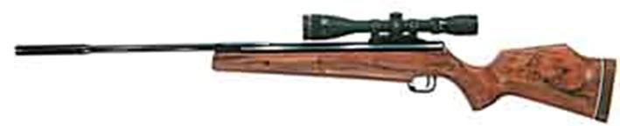

Muzzle Brake on Beeman/Theoben Crow Magnum

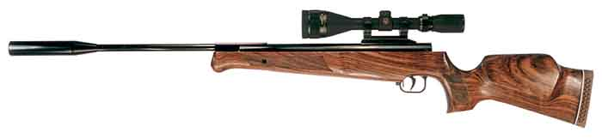
Integral Moderator on Theoben Eliminator

Ammunition:
The preferred ammunition for airguns is carefully chosen pellets made of lead or a lead alloy. Lead-free substitutes are available but lag far behind traditional pellets in accuracy, range, and cost. Serious shooters test multiple pellets in each of their guns to find the pellet with the best accuracy. I suggest buying a multi-brand pellet sampler with your first airgun to test different types and brands. Even a beginner shooting at 10 yards will learn which pellets suit their gun best. Also, pellets of the same caliber have slight variations in size. Generally, pellets perform best with a fit between lightly snug and tight when loaded. Loose fitting pellets are never recommended.

You will also find pellets at your local sporting goods retailer. These are usually the lower-end pellets, which may shoot accurately in your gun, or they may not. Most regular airgunners stick to the high-quality pellets purchased from the airgun specialty suppliers for their superior consistency and availability.

Pellet weight is another factor. Pellet weight is traditionally measured in grains. Heavier pellets tend to capture more of the guns firing energy and retain it further downrange with less wind deflection. Lighter pellets move faster and drop less before reaching the target. Spring-piston guns generally do best with pellets of middle weight, and powerful PCPs can gather tremendous energy from the very heavy pellets. Changing pellets after a gun is sighted in will usually change the point of impact, and will therefore require re-sighting the scope. PCP users also report better results if the pellets are washed, dried, and lightly lubricated. Springer shooters may benefit from washing pellets, but lubricating them is unnecessary and can even cause dieseling.

Wadcutter (Match) pellets have flat leading faces that cut clean, easily scored holes in paper targets. These pellets shoot very accurately at match-gun ranges (10 meters) and velocities (500-650 fps), but not as well at longer ranges and higher velocities. They are usually available in light to mid weights.
Diabolos (domes) are the name for round-headed pellets that taper to a waist and then back out to a full-diameter skirt. These pellets are excellent for long-range shooting and hunting due to their aerodynamics. They are the preferred type for use in hunting and field target shooting.
Pointed Pellets are specially designed for hunting and can penetrate into game that have tough, bony skulls.
Hollow Point Pellets resemble diabolo pellets but have a cupped head that causes extra damage when it hits an animal.
Round lead balls are another option, but do not confuse them with ordinary BBs. Do not use ordinary BBs in a quality airgun because damage can occur to the rifling.

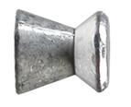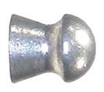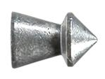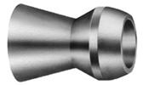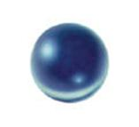
Pellet Styles, Left-Right: Wadcutter (Beeman H&N Match), Diabolo (Crosman Premiere), Pointed (RWS SuperPoint), Hollow Point (Beeman Crow Magnum), Round (Gamo Roundball)

Shooting Technique:
Even though airguns are not as powerful as firearms, basic safety precautions are critical. I have kept this list concise for readability, so please read it in addition to the literature provided with your airgun equipment.
• Always wear safety glasses or prescription glasses with side shields.
• Only shoot at adequate backstops, in an area where no people, children, or animals can get in the way.
• Always hold the cocking lever of a springer with one hand while loading the pellet, and keep things clear of the trigger. If the trigger is pulled with the lever retracted, the lever or barrel can slam shut on your fingers.
• Never rely on the gun’s safety to prevent firing. Air guns should not be loaded when not in use. The safest way to unload an airgun is to shoot it into a safe backstop.
• Handle the gun with the gun chamber open or break-barrel open to demonstrate it is unloaded.
• Do not leave a spring-piston gun cocked for extended periods of time. Do not fire it without a pellet properly loaded (the lack of resistance can damage the piston and spring). Do not get any oils or contaminants on your pellets or in the breech area or dieseling may occur. Do not disassemble your springer without proper tools and a good understanding of correct spring de-compression (yes, the spring is still partially compressed when uncocked).
• Treat all PCP equipment carefully with the correct precautions, as charged PCP tanks have tremendous explosive energy. Always follow the proper procedure when filling or discharging the guns reservoir.
• Do not store pumpers pumped, except for modified Sheridans, which must be stored pumped according to the special instructions.
• Be aware that pellet dust and lead vapors are poisonous. Do not smoke while handling pellets and wash your hands afterwards. Keep pellets and pellet traps away from kids and pets.

Proper hold of an airgun is similar to a firearm. With PCPs and pumpers, the basic marksmanship guidelines necessary for an accurate shot apply: breathing control, a solid stance, steady aim, and smooth trigger pull. The early recoil of spring-piston guns make them a special case. Springers are best handled by a soft hold, and the location and pressure of your hands and cheek must be extremely consistent from one shot to the next. When held correctly (nicknamed the ‘howitzer hold’), the shooter allows the recoil to make the gun jump rearward a bit in their hands. With practice the shooter will also relax and reduce their reaction to the recoil, another source of inaccuracy. Shooting from a hard rest or clamped gun vise will usually make a springer lose accuracy. Most springers gain maximum accuracy when supported at one particular location on the forestock. Experimentation is required to find this point on each gun. There is greater detail on shooting technique in articles written by airgunners who are far better and more experienced shooters than I am, so for further information refer to them.

Pellet drop is more pronounced than bullet drop due to the reduced velocities. Shooting at different ranges necessitates knowing the amount of drop you'll get from the pellet, especially beyond 40 yards. Most shooters like to sight in their scopes at 20-30 yards, where the pellet trajectory is as at its apex relative to the barrel and scope. This means for shorter and longer ranges, the shooter must hold the crosshairs above the target (holdover) or adjust the scope elevation before shooting. Mil-dot reticles, originally designed for use with long-range firearm shooting, work very well to make the holdover method more precise and repeatable. Of course, it takes practice to learn the relationship of the mil dots for any particular gun and pellet.

The basic shooting positions are standing (offhand), seated, kneeling, and prone. Shooting seated off of a bench rest is also useful for practice and learning the characteristics of a new gun. The most accurate freestanding position is prone, followed closely by the seated position. Standing requires the most practice to master, and is best learned after becoming proficient at shooting the other positions. Refer to the US Army Marksmanship handbook, Field Target websites, or Match shooting websites for more details. Consider adding a sling to your PCP rifle if you do a lot of standing shooting (however springer accuracy may suffer if a tight sling support is used).

Care and Maintenance:
Maintenance is easier than you think: if in doubt, don't. Really, most airguns don’t need special attention until they begin sounding or shooting differently. Modern airguns require little more than a proper wipe down of the blued surfaces and an occasional bore cleaning. I use a silicone impregnated cloth for cleaning the metal of my guns, and others recommend a few drops of RemOil or similar wiped on with a cloth. The cocking linkage and pivots benefit from a drop of oil when they dry out. Because the airguns are made from the same materials as regular guns, rain, condensation, and other corrosive effects must be correctly handled. Check for loose screws – only tighten them to snug – do not torque them down hard. It is usually a good idea to degrease and use ‘blue’ Loc-Tite or similar temporary thread lock to reduce this problem. On springer, this extra step is strongly recommended for the screws holding the stock to the action.

There are products for oiling the chamber and spring of spring-piston rifles that are not necessary for modern airguns. Using them can even be detrimental in many cases. Generally, the factory lubrication is enough for the bore, near the breech seal, and inside the piston chamber. If petroleum-based oil or grease gets inside the bore, a springer may diesel. Dieseling is when the intensely compressed air causes the oil vapors to ignite, resulting a louder discharge and odor. If you suspect dieseling, try to clean the areas with dry patches as best as possible, and then shoot several heavy pellets to diesel off the material in a minimum amount of shots.

Cleaning the bore should be done with a non-scratching pull-through cord and cleaning patch. Just a couple of pulls with the patch is usually ample for a thousand shots or when accuracy changes. Certain guns and a few brands of pellets may require cleaning a little more often.

Most airguns (especially springers) display a break-in period of a thousand shots or more where the mechanical parts wear to fit each other. You just shoot, shoot, shoot. Usually by a thousand shots an airgun is more accurate, velocities are higher, and the feel is smoother than when the gun was new. Any replacement of the piston, chamber, guides, or spring will require another break-in period, as in the case of a mechanical tune.

Sometimes seals and springs wear out or break and require replacement. This is detected through a change or inconsistency in velocity with the same type of pellet, reduced accuracy, or a different behavior of the gun.

Accessories:
There are as many accessories as there are guns available. I will cover what I consider the most versatile and general ones.

Backstops and Traps
Every shooter should be acutely aware of what they're shooting at, and pellet traps are a necessity for all indoor and most outdoor ranges. I have had good experience with my homemade “silent” trap: a 12" x 12" frame made from 1x4s with a 1/2" polyethylene backplate, filled 2" deep with Duct Seal putty (similar to ballistic putty). I strongly recommend this type of trap, especially to prevent bounce back and to contain the toxic lead dust. Other indoor trap designs include heavy wooden sheets, boxes packed tight with paper, old phone books, and more. For indoor shooting take precautions to contain and clean the lead dust around the trap.

Plinking cans and small items in a backyard is relatively safe if the shooter is careful to not shoot at or near any objects that could rebound the pellet. Golf balls are an example of what not to shoot. The dangerous range of an airgun can approach 400 yards.

Chronographs are used to directly measure the velocity of a shot, and can be used to determine the pellet velocity downrange, important for humane hunting. They are also helpful in choosing the most effective pellet for your gun and diagnosing powerplant problems.

Shooting gloves are often used on the left hand (for right-handed shooters) to more gently support the weight of the gun and to reduce the effects of your pulse on your aim. They can promote a more relaxed consistent hold - always an improvement.

Shooters should always wear glasses. Safety glasses are critical for safety in accidents involving a bounced-back pellet or an accidental discharge of pressurized air. There are a lot of body parts that can heal and mend, your eyes are not one of them. So just get in the habit of wearing shooting glasses. In addition, shooting-specific glasses can improve acuity and provide prescription vision correction.

Tuning is the term used for aftermarket modification to your airgun. Generally these modifications do not stray far from the factory design, but use optimized lubes and hand finishing with precision fit parts which could not economically produced in a factory setting. Spring-piston actions can usually be modified to eliminate their 'twang' and reduce the vibrations of recoil. Springer power can also be modified by changing springs according to the shooters desire for either more accuracy, more power, or easier cocking. Whether changing springs directly improves accuracy is a little debatable, but it's clear to me that any given shooter will tend to shoot a tuned springer better, and certainly enjoy it more. PCP airguns can be tweaked to maximize the number of usable shots on an air fill with a minimum variation in shot velocity, leading to an improvement in accuracy. Tuners will often find small manufacturing flaws and fix them as they go, making a direct improvement in these cases. Trigger tuning smoothes the action of factory triggers. Custom stocks can be made optimized for a shooters favorite shooting positions and style.

Where to Buy:
This can be the most confusing subject. No one reseller carries all the major brands because of the difficulties of stocking imported items. Adult airguns are usually manufactured in the UK, Germany, Spain, China, and the Czech Republic. They are sold in the US as either their original foreign brand (i.e. Weirauch, Webley, Theoben) or relabeled (i.e. RWS, Beeman, Gamo). Airgunners often rely on mail-ordering from airgun specialty shops since these shops aren't usually within driving distance. In many cases, used guns can be found in excellent condition, even tuned and with accessories for less than a new gun.
(Buyer beware though: there is always a small risk of a bad seller, so airgun buyers should take extra precautions). I will not list any classifieds or retailers here out of fairness. A quick web search will turn up links to resellers and recommendations by fellow airgunners. By and large, I feel airgun sellers in the US are very helpful and sincere in their business efforts.

Some notes for online buying: not all suppliers carry ‘every’ accessory or model that the typical airgunner will want. Expect to shop around some.

Types of Shooting:
Hunting for small game is popular. Airgun hunters enjoy the ability to discretely and humanely kill nuisance birds, vermin, rabbits, squirrels, and more. Hunting with airguns requires that the hunter understand the performance of their airgun and pellets, the vital organs of their quarry (usually head or heart/lungs), and concealment or stalking to get within range. I strongly encourage you to do some research before taking aim at any living animal to ensure a humane kill. Some have hard skulls that require special shot placement, others, like jackrabbits can actually jump on the sound of the shot and cause a miss. Range, wind, and airgun power also affect the limitations of a humane kill. Hunting requires the shooter to make accurate, consistent shots in field conditions, so I suggest starting conservatively instead of trying to repeat the 50 yard shots documented by others. Good hunters put in good practice and know their capabilities.

Pest Control is very similar to hunting, except the location, tactics, and motivations are different. In the case of pest control, the shooter often has the advantage of setting up their vantage point and baiting their location. Common species include the English Sparrow and European Starling (aggressive non-native birds), gophers, woodchucks/groundhogs, nutria, squirrels, rabbits, crows, and more. The season and limits for these species vary seasonally and from state-to-state, so check with local authorities even if you will be on private property. It should go without stating to limit your shooting to animals that are true pest species.

Plinking is any shooting for the sake of shooting. Shoot whatever you find most gratifying, whether it’s aspirin tablets, plastic army figures, walnuts, acorns, swinging targets, or paintballs. Nobody’s going to give you a hard time for shooting things just to give you grins – airgunners know how to play.

Target competition is typically done indoors at 10 meter range. Using non-magnifying sights, shooters attempt to strike a tiny bullseye using the standing position. Special airguns, pellets, clothing, spotting scopes, and more are only a small part of the equation – these shooters practice endlessly to build their fantastic abilities.

Field Target is a type of rifle competition that is much closer to the plinking and hunting side of airgunning. Metal knock-down targets are placed at varying distances and locations. Competitors shoot from a defined area using only certain positions, taking one shot at each target without external aids for determining range and wind. Scoring is simply the total number of knockdowns. Field Target shooters have developed an interesting use of adjustable-objective scopes: they use a scope at very high magnification (e.g. 32x) and focus on the target. Because of the sensitivity of focusing at this magnification, the shooter acquires an accurate estimate of the target range. This is then used in determining correct holdover for the shot. Field Target is excellent means of honing a shooter’s skills and is also a complete activity in itself.

Further Information
http://www.airguninfo.com/ – one airgunner’s personal link list to manufacturers, resellers, discussion forums, and other personal pages. There are many commercial links that I highly recommend listed on this page.
Flash airgun illustrations – excellent animated explanations of airgunning phenomena such as parallax, spring-piston recoil, and many more.
http://www.bigboreairguns.com/ – This site carries a great list of airgunning books.
Fun Supply Airgun Forum – a special thanks go to the regulars of this group for providing the author with his start into adult airguns. One of many active online airgunning forums.

