Maintaining Your Airgun (Generic)
By Charlie
6/01/06

This applies to the general external maintenance of all springer and gas ram guns. The different guns and models may vary but the principles remain the same.

Rem-Oil is a good all-around maintenance product on the wood, plastic and exterior metal although any good general purpose gun lube will work just fine.

Externally it should be lubed about every three thousand rounds or so, or once a year. It is a simple procedure. If your gun is put away for long periods of time, it should be fired every three months or so with about 5 shots or so it may lube itself.

The best lube to use is a mixture of moly and 30wt non-detergent oil. Mix it 1 teaspoon of moly to three ounces of oil. Shake well to be sure it mixes well. Lube very sparingly. I use a tooth pick dipped it the mixture and put only a drop or so. If moly is unavailable, use 30wt non-detergent oil, again, very sparingly.

First remove the stock by removing the two screws located in the forestock and the rear screw in the trigger housing. These are usually Phillips screws or Torx # 25 screws. The assembly lifts out of the stock although sometimes it is a tight fit at the trigger end. Use good screwdrivers as these screws are often installed with LocTite during final assembly to keep them from loosening. Also, be aware of the little roller,washer and glide as they may fall out when removing the stock. See below…

Glide and Roller

On the Gamo, Gamo clones and Crosman clones of the Gamo, there is a little U shaped part that fits/sets on the cocking linkage and that is the glide (not guide) that on some guns may fall off. It prevents metal to metal contact between the action and cocking linkage when cocking the gun. With the action and linkage facing up and the barrel facing to the right, it fits into the notch on the bottom of the cocking linkage between the action and the linkage. There are usually two notches (some of the Chinese clones have only one) in the linkage. (See the pic below) With the barrel facing to your right, it goes in the notch closest to the barrel (furthest from the roller) with the narrow part (if there is one) of the glide facing you as you install it. See the Pic below.

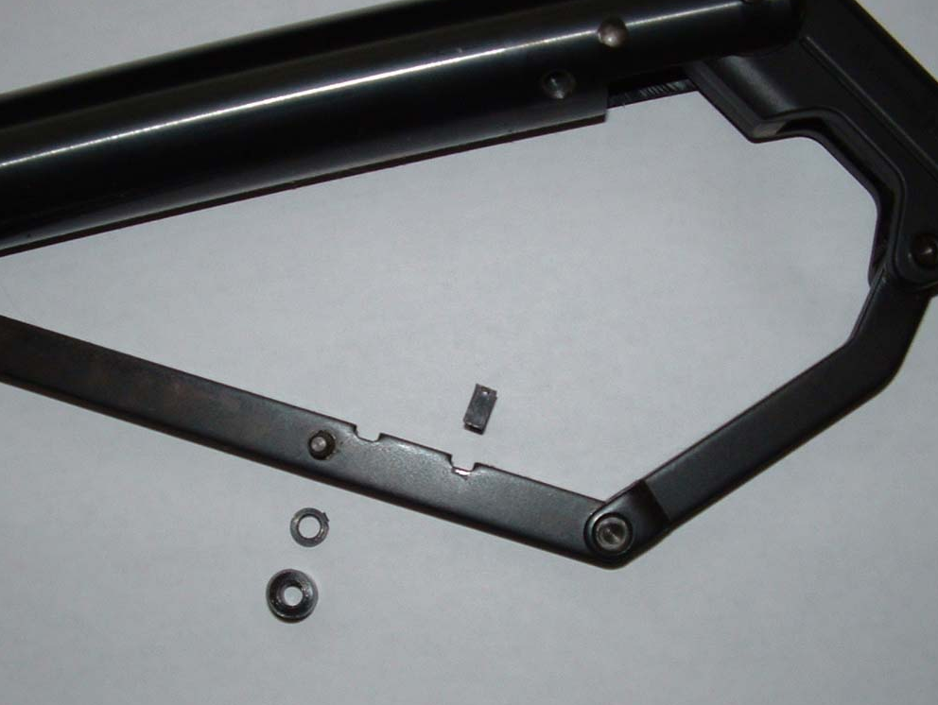

The roller goes on the pin on the side of the cocking linkage. There may also be a small washer spacer that sets on the pin also. If so, then the washer goes on first, then the roller.

There may also be a centering insert for the lug behind the trigger that sets in the stock behind the trigger slot on some guns including all of the Gamo’s, most Gamo clones and Crosman clones of the Gamo. This quite often falls out when the stock is removed. They do differ from gun to gun but see the picture below.

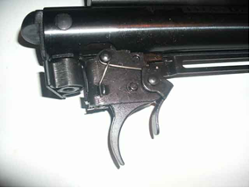

Lube all of the pivot points where you see the rivets, three or four drops spread out into the trigger mechanism and the pivot pins from the trigger (bottom), both sides of the cocking pivot point or yoke, the barrel latch points taking care not to get any into the muzzle or port, three drops into the slot that you can look into the cocking foot and a drop or two on the cocking foot itself.

Cleaning the bore

The best thing for cleaning the bore is GooGone or Simple Green. You can find it at just about any hardware store, Wal-Marts and K-marts, and places like Home Depot or Lowe’s. DO NOT USE ANY METAL BORE BRUSH IN YOU BARREL. Use only a Nylon bore brush.

Strip Cleaning: One way to do it is to use is a piece of trimmer line, the plastic or nylon line used on grass trimmers, cut to the length that is best for you, heat it on one end to create a small flat surface and on the other end cut it to a point. Using .22 bore cleaning patches, push the sharp end of the line through the patch(s) (you will need to punch a small hole in the patches with a sharpened small finishing nail or something similar), then put some GooGone on the patches and pull them through the bore. Do this several times first with the ones with the GooGone and then dry patches until they come through clean. This is what I refer to as “Strip Cleaning” and should rarely be done.

Normal cleaning should be done using the above procedure but do not use the GooGone and use only cleaning patches.

By the way, the bore doesn't have to be cleaned very often, maybe every three or four tins of pellets. The lead deposits accumulated in the bore act as a lube as well as a seal for the pellets and can increase both accuracy and velocity.

NOTE….Important….READ THIS: Do not use heavy pellets in your gun. Although heavy pellets such as the Kodiaks will not damage Co2, PCP, and Pumper type airguns, they can and will sometimes cause severe damage to the main spring in Springer Guns. Both the light and heavy pellets can cause damage and spring fatigue beginning with just a few shots and when disassembled, the damage caused by heavy pellets and detonation is easily detected and identifiable. Also, light weight pellets can also cause severe damage. The spring failure is usually not the fault of the spring. You will be responsible for any damage caused by the use of incorrect pellet weights. Use heavy pellets or light pellets at your own risk and expense.

For the longevity of your spring gun
My suggestions for .177 caliber gun that the min. wt. be 7.0 and max. pellet wt. should be 9 grains.
My suggestions for .22 caliber gun that the min. wt. be 12.0 and max. pellet weight should be 16 grains.

Bob Werner

Also known as: Charlie

