A little extra safety for those Underlevers and Sidecockers
By Charlie

Note: This will not apply to break barrels.

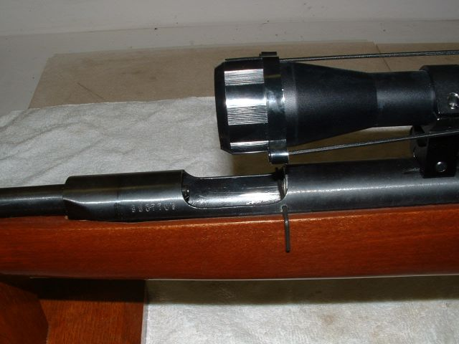
Modified Fast Deer (Norinco KL-B3) showing pin

Please read this in it’s entirety before proceeding.

Give the project some thought and prepare yourself with the necessary tools and parts. This should not be a difficult project for persons with a little mechanical knowledge and skills, and some basic hand tools. I take no responsibility for any mishaps, damage to your guns, or personal injuries. Working on airguns can be dangerous, and if/when you work on them you take full responsibility upon yourself.
Have fun with your gun.

As I was browsing the forums the other day, the bear trap and safety question came up again. It crosses my mind every time I use those guns.

As most of you know, I have a couple of Fast Deers and a B-4-2. There has always been a question of safety (and also a few incidences) of the accidental release or the gun going off while inserting a pellet. The cylinder slams home and you wind up with a big hurtie, maybe even a lopped off finger tip. Of course if you hold back the cocking lever as you load it (and you should), it shouldn’t be any problem. But as everybody knows, sometimes we forget, or maybe get in a hurry or careless. When you have a scope mounted on these guns it makes it even more difficult. There have been few solutions for the problem. One of them is placing a small piece of wood or dowel in the breech It works, but gives you much less room to insert the pellet, especially if using a scope as seen in one of the pictures. And on my b-4-2 the pellets fit tight even after the breech mod, requiring a little fidgeting and finesse to get it in.

So I got out OLD UGLY (KL-3B “Fast Deer” it’s not ugly really) and started giving it some thought. I posted an idea on the yellow pages a few days ago. Not too much response although I’ve read concerns about it in the past.

So…for what it’s worth, here’s what I did.

Note:
The best time to do this is if you are disassembling the gun, however, it can be down with out tearing it down. If done while not tearing it down, it requires being very careful. Personally, I feel that it should be done with every gun if it’s disassembled.

First I removed the scope and laid the gun down on its side and with the cocking lever facing down on the bench. Taking a sharp pencil, I drew a line the length of the breech at the point where the receiver cradles into the stock as close to the wood as possible. Marking the other side (cocking lever side) isn’t necessary.
Cut a small piece of wood or dowel about 1 ½ inches long. This will act as a temporary safety and will be placed in the loading chamber while proceeding with the next steps.

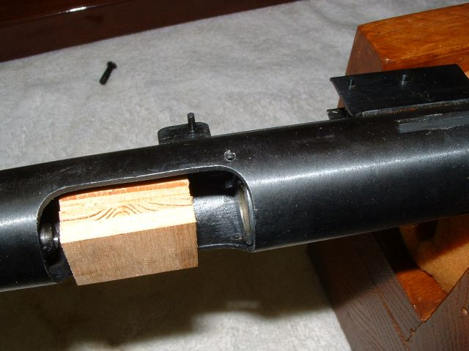
Chamber showing block placement

Now cock the gun and place your block in the chamber. Draw a vertical short line about 1/8 inch to 3/16 inch in front of where the cylinder is recessed into the assembly (the open chamber) up to the horizontal mark. This mark does not have to be exact, but close.

Remove the block, put a pellet in the chamber and discharge it, outside preferably.

Now remove the front stock screw and the two screws holding the trigger housing and set the stock aside.

Looking at the horizontal line you should have roughly about ¼ inch between the line and the opening for the breech. Your vertical mark should be roughly at the leading edge of the curve of the breech opening. Shortly you are going to drill a small hole 3/32 inch in diameter through the breech from the side with the lines and through the opposite side as straight as possible.

Do this by centering a sharply pointed center punch between the horizontal line and the breech opening, and at a point in the center of the vertical line. Lightly tap the center punch several times to create a dimple to start the drill bit. There is room for a little error on the side cockers, but less room for error on the under barrel cockers.

DO NOT DRILL YET

Now comes a point where you must be careful if you are doing this without the gun disassembled.

Caution from this point on.

First, cock the gun.

Now roll two small pieces of tissue rolled into cone shaped pieces. Carefully place these pieces of tissue (with the block in place if possible) into the port as well as the pellet receiver in the barrel while holding the cocking lever. (The logic here is to keep any metal shavings out of these areas.)

Next place the wooden dowel (or what ever small block you use) into the receiver and place a piece of tape or wire tie around the barrel/receiver holding the block in place so that it will not fall out while working on it, placing the block closest to the barrel end of the loading chamber. You want to leave enough space toward the rear so as not to interfere with the drilling process.

Place the receiver assembly into a holding device such as a vice making it as level horizontally and vertically as possible. In my case I have a small drill press with a vise adapter making it easy. Make it as secure as possible with your punch mark facing up. Now it’s just a matter of drilling the holes. Chuck the drill bit up close to the chuck jaws at first for bit stability. Care must be taken after passing through the first side and starting into the opposite side as the drill bit will have a tendency to want to bend and if to much pressure is applied the bit will break because of the curvature on the inside. Just take you time.

After it is drilled out clean the burrs from the holes paying particular attention to the inside edges of the holes so as not to damage the cylinder when it slides back and forth. Carefully remove the tape and safety block (keep in mind that there is no protection with the block removed) and clean out all of the metal shavings. I used a pencil magnet first, and then blew it out clean. Remove the tissue that protected the ports.

Place a pellet in the chamber and discharge it. Now you can reinstall the stock and scope.

As you can see in the pictures, I used an Allen wrench as the safety tool, as it is made from hardened steel and easy to grasp and maneuver, however, any steel pin such as a roll pin could be used as long as it fits, and is close to the hole diameter. Just be sure it is of hardened material.

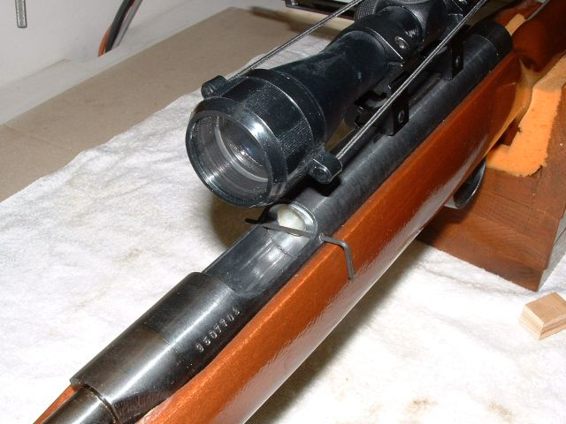

As you can see, the pin crosses passing through just in front of the cylinder

Note: you should consider a little larger pin if employing in a larger gun like a B-21/22.

Charlie

