A Scope Shim Guide
By Charlie

DISTANCE IN THICKNESS CHANGE IN
YARDS OF SHIM INCHES
25 .001 0.25
50 .001 0.50
100 .001 1.00
25 .002 0.50
50 .002 1.00
100 .002 2.00
25 .003 0.75
50 .003 1.50
100 .003 3.00
25 .004 1.00
50 .004 2.00
100 .004 4.00
25 .005 1.25
50 .005 2.50
100 .005 5.00

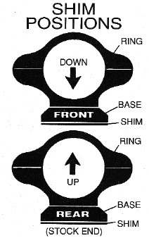

FOR MAJOR ELEVATION ADJUSTMENTS:

35mm negative film is .005 inches thick and a good shim material. Cut for a good fit.
Shimming can be done in the lower half of the ring also, but great care must be taken.
Over adjusting of elevation and windage may lead to internal damage of your riflescope.

• Shim the front of the base for additional downward movement
• Shim the rear of the base for additional upward movement
• Major windage adjustments require the use of a windage adjustable mount
• Best results will be with using the lowest profile mounts possible.

