A few B-19 and Gamo fixes
By Charlie 8/10/03 (revised 2/20/04)

Some more “stuff” from Charlie

Here are a couple of ideas for you to tinker with. These are just general descriptions and not exact and when I get some time, perhaps I can be a bit more descriptive and exact with some better pics.

There are a couple of small plastic parts that seem to either get lost or broken or worn out and are pretty hard to come by. Fortunately they are pretty simple to make although can take a little time. Those parts are the cocking linkage rollers which have a tendency to flatten out over time and cause rough cocking, especially on the B-19’s and Gamo’s with wooden stocks and the little plastic glide on the cocking bar that prevents the arm from rubbing metal against metal against the tube. These often break and/or simply fall out and get lost.

The material need is available at many craft and hobby stored and is very inexpensive. If you have a lathe and a small milling machine, they are a snap to make but with a little time and patience, you can make them by hand. Just a fun project. The tools needed are a drill press or a 3/8 in drill and a couple of drill bits, an Exacto Knife or a good sharp single edge razor blade, a file fine file and a little sandpaper. These parts need not be perfect but should be fairly close.

The cocking rollers

They should be made from a good plastic (not a hard brittle plastic) or Delrin rod 3/8 inch in diameter. The rollers are one of two sizes depending on the gun. The roller pivot hole is the same in all of them but the outside diameter and width can be different.

The smaller of the two rollers has a pivot hole diameter of 9/32 (or a #22) drill bit. The outside diameter of the roller is approximately 11/31 or 9mm and the width is 5/16 or 8mm.

The larger of the two rollers also has a pivot hole diameter of 9/32 (or a #22) drill bit. The outside diameter of the roller is approximately 7/16 or 11mm and the width is 11/32 or 9mm.

Simply drill the pivot hole in the center of a small piece, then chuck it up in a drill press or drill motor and shape it down to the desired OD, cut it off just a bit long and sand it down to the desired width.

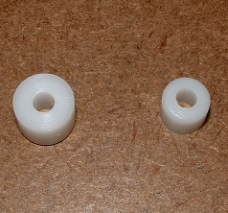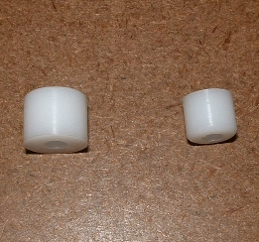

The cocking glide

The little cocking glide is important and many do not realize that it is there or if missing, don’t realize that it was there. They quite often break in two and fall out. When it’s not there or worn out, the cocking lever starts rubbing on the tube and given enough time could actually wear through it although I have never seen one that bad.

This can be a bit more difficult to make and a bit more time consuming. They too should be made from a good plastic (not a hard brittle plastic). They can be made from either 3/8 inch square stock or rod 3/8 inch (I prefer Delrin) or something similar in diameter. I’ve made them both ways but prefer making them from round stock as in the picture. I don’t have a pic of the square one but this will give you a general idea if you use square stock. The pic is from Delrin.

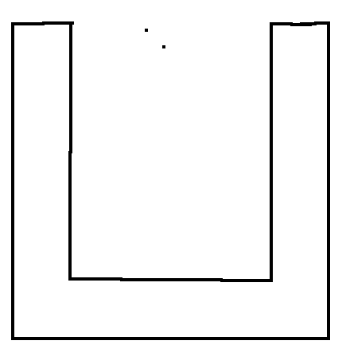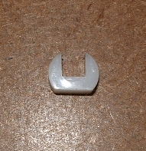

Just cut an inside notch that is 3/16 or 5mm wide. Cut the depth of the slot so that you have a bottom that will be 3/32 to 1/8 inch thick where it seats in the cocking lever. The thickness should be about 5/32 or 4 mm. You can also shape the bottom to match the tube but it really isn’t necessary. It has less friction as is and given enough time, will wear and form itself to the tube anyway. There is enough information here that I think you get the general idea of what you need to do.

Another solution for those of you that have a CFX.

On many of the Gamo CFX there is a fairly common problem with the little thumb lever that is used to rotate the breech. It allows the breech to rotate just a little further than it should and allowing too much travel causing it to be off center and the pellet guide will not allow the pellet to slide smoothly into the chamber. For those that have a little ability, you can pop the old one out (watch for the little spring clip when you remove it) and make a new one out of perhaps several different materials including Aluminum, Brass or even Delrin or plastic. Just whittle out a new one and but make small shoulder a little wider (the stop) on the side of the lever to stop it just a bit sooner as it is rotated (opened). Shape the thumb part to what ever you might like. Check it as you go until you get to the point where the pellet guide and the muzzle are lined up. You will need to drill a very small hole down the center and thread it then cut a fine slot. Then insert a small screw into the hole and tighten to expand the wall of the material so that it locks the lever in place. I have made several of these and it works real well. No longer will you have a problem inserting pellets or shaving the pellet skirt as you rotate the and close it. The next time I make one I will add a picture.

There is another simple alternative to resolving this also. You can cut a thin shim from metal or plastic and Super Glue it to the edge of the lever. It’s a matter of finding a thickness that will work. Just set the lever in position so the pellet accesses the bore and get an idea of just how thick it need to be. Be very careful though that you do not get any Super Glue in the slot or rotary before it dries. It’s best to set it up and glue it with the lever out of the rotary.

I have had a few people suggest that I make and market the above fixes but it’s really not worth it unless there was a demand for them, which at this time there is not. Perhaps in the future. I wouldn’t doubt that when people read this, someone will copy the idea and make and sell them anyhow and that’s ok too. That’s what usually happens and then they like to claim them as there own….lol… Besides, someone in past years has already done these things before me and their probably not new anyhow. It ain’t like I invented the wheel….lol… It’s just the way it goes.

Bob: aka.. CharlieDaTuna

