GRT-III in Stoeger X10/X20/x50
The GRT-III trigger will work in the Stoeger X10, X20 and X50. It is a drop in. The only thing that you need to do in addition to the general instructions is file about twenty to thirty thousandths (.020-.030) or (.6-.8mm) off the top of safety tab on the safety link or just enough so it can pass under the pin. Remove just a little at a time and check it as you go.
BE CAREFUL… take care to not remove more than needed to pass under the pin because if you do, the safety will not work.
Just remove the e-clip from the pin that is passing through the safety link (DO NOT REMOVE THE PIN) and one end of the little spring from the back of the linkage so that it can be moved to give you a little working room. Reinstall when complete.

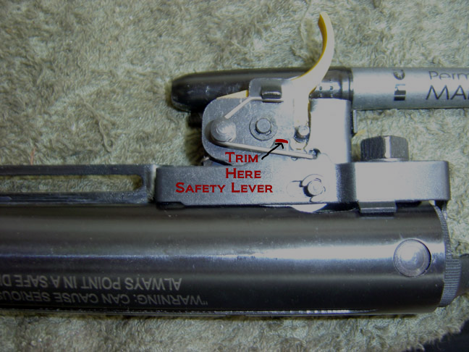
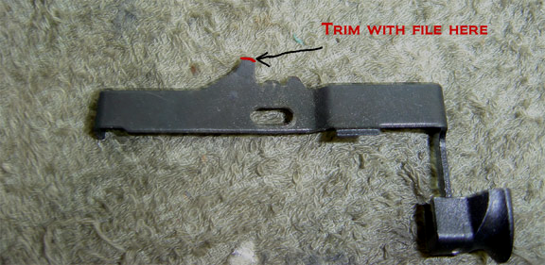

To see the complete installation Instruction, click the link below.
http://www.youtube.com/watch?v=nmi6I2mceQs

