Springers can be dangerous
« on: June 02, 2007, 04:41:17 AM »

Hey guys I post this as proof that we should heed the warnings about handling springer’s. Especially with regard to getting fingers in the breach area while holding onto the barrel. I didn't. My gun malfunctioned and I'm paying - not as bad as I might have but close. I nearly lopped a big chunk out of my left thumb.
It started with a tuned rifle that had the trigger pull greatly reduced - probably too reduced. I cocked the gun then realized in my haste to shoot it, I hadn't got a can of pellets opened and into easy reach first. So I reached far up on a shelf to get a can and in the process let my thumb get into the breach area. The trigger released forcing the barrel to slam closed on the tip of my left thumb. This is a BSA SuperSport - a lower end "magnum" air rifle.
The hide off the top of my thumb has disappeared the bone was shattered and the pad of my thumb was nearly cut off. Luckily hitting bone seems to have deflected my thumb out of the breach area and I didn't have to open the gun to get it out.
Once at the emergency room I was grateful for several shots of lidocane to the thumb before x-ray, cleaning, removal of some bone, and stitching was done. For a while the Dr. thought he'd have to just finish the removal job which would have left me with a heck of a notch and a big open wound. But enough circulation remained that he decided to stitch me together after removing a 3/16 inch chunk of bone that had been driven down into flesh. It took about 45 min to an hour to sew up and 16 stitches. Hard part was on the top of my thumb where there was nothing to sew to.

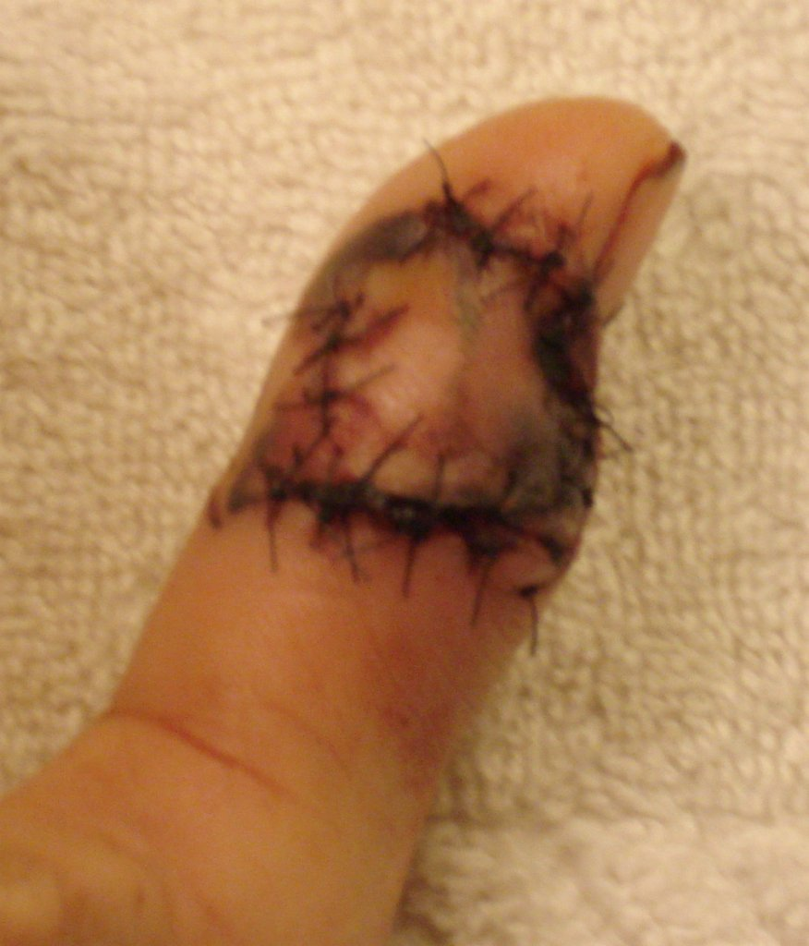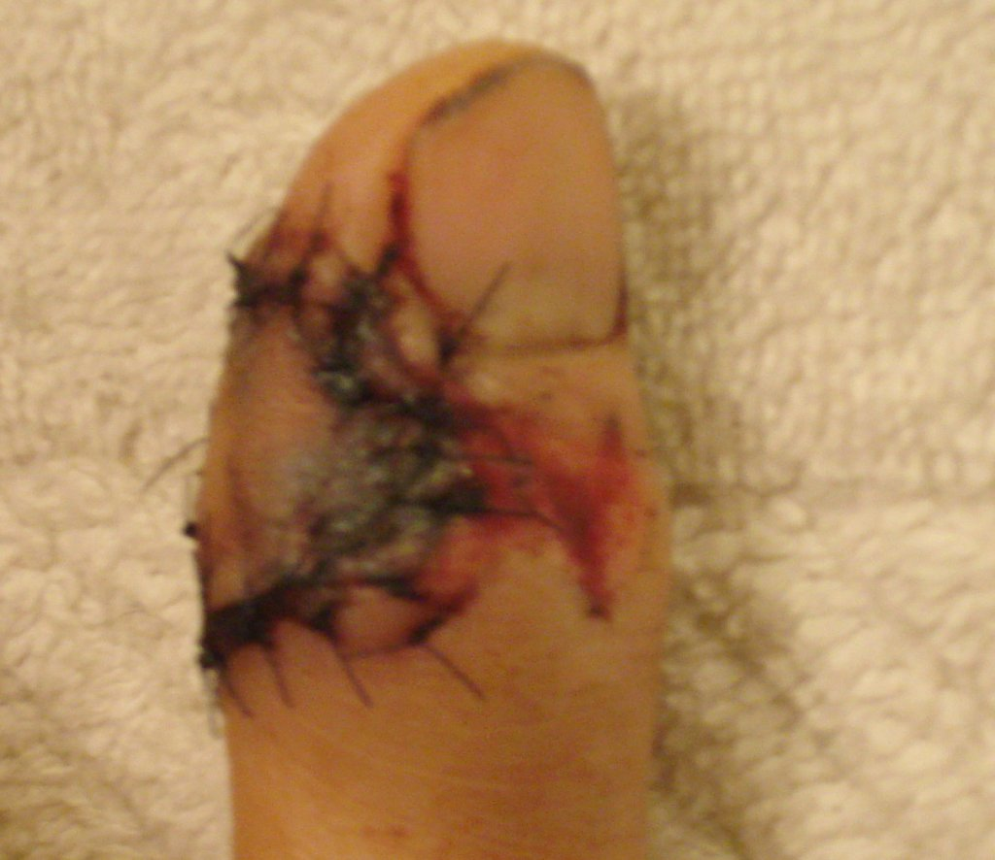

So, its been 2 weeks and the stitches are out. I have to really protect it so I don't open it up. I'm lucky that it doesn't hurt real deep most of the time. Usually feels numb or like I'm touching a very high speed sander. But there is some sharp stinging along the top. But it looks like the joint wasn't ruined and I hope to regain movement of it. They say it might take several months though.
Oh, and after getting sewed up I checked the gun thinking I had somehow tripped the trigger with my shirt or bumping something. I doubt that now. First 2 tries to test fire, the trigger released by itself before I could get the gun pointed to my target trap - 2 holes in the sheet rock. And I was being VERY careful. A few days later I try the gun again (outside now) and the gun was fine for 3 shots. Yesterday I tried the gun for 2 shots again outside. First shot fine, second time the trigger again released on its own!
The gun never did this before the tune. I have to figure out how to make it safe.
Anyway - the manuals often say don't let go of the barrel while loading a pellet and keep things out of the breach area. Heed the warnings. They ain't a kidding.

